DevSecOps Three-Tier Project using AWS EKS, ArgoCD, Prometheus, Grafana and Jenkins

Create dynamodb

aws dynamodb create-table `
--table-name Lock-Files `
--attribute-definitions AttributeName=LockID,AttributeType=S `
--key-schema AttributeName=LockID,KeyType=HASH `
--billing-mode PAY_PER_REQUEST `
--region ap-south-1

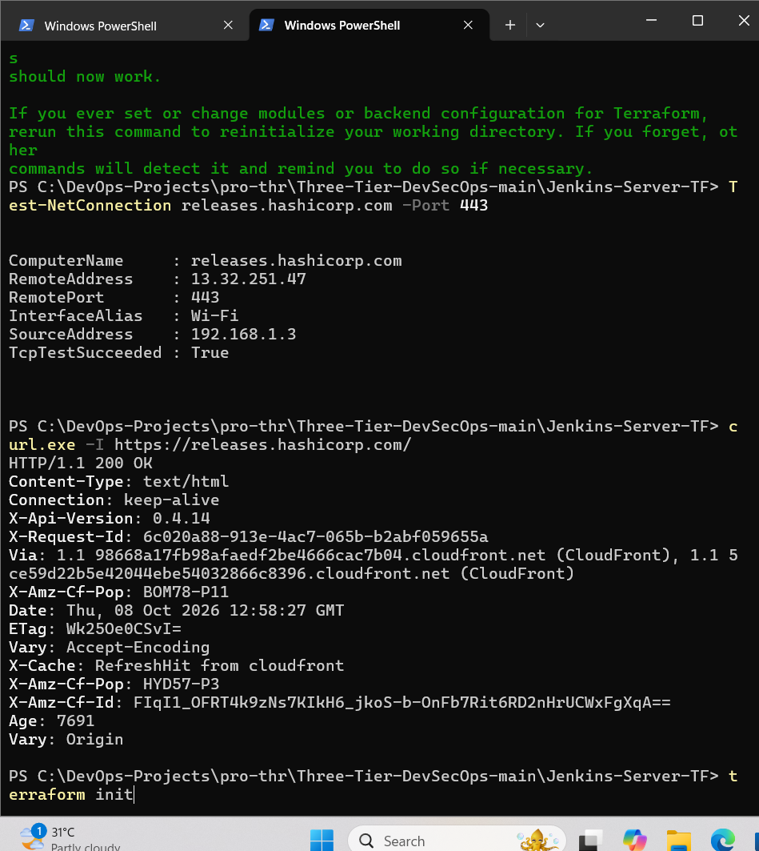

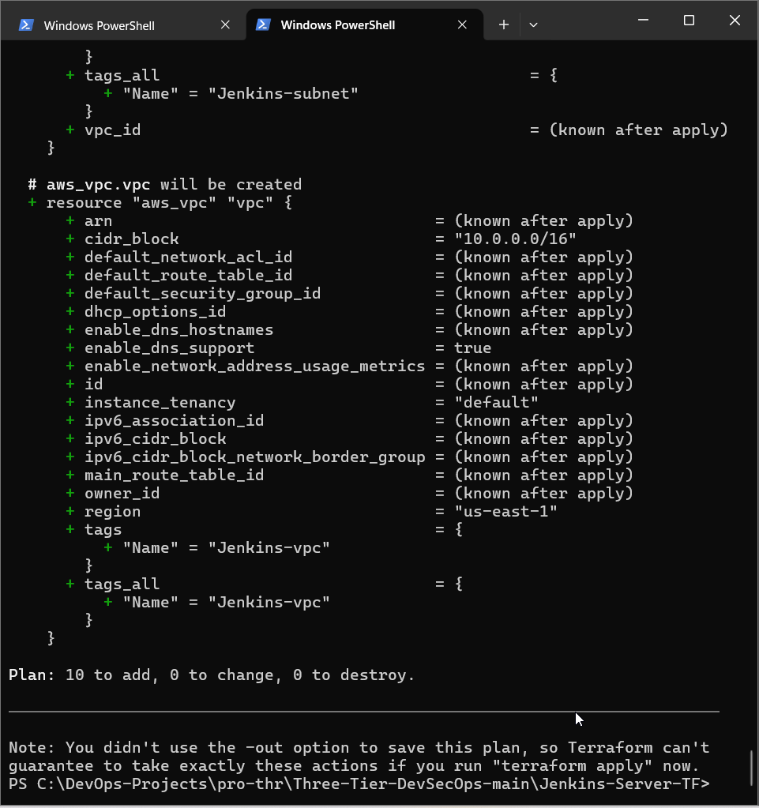

terraform import "-var-file=.\variables.tfvars" aws_iam_role.iam-role Jenkins-iam-role
terraform import "-var-file=.\variables.tfvars" aws_iam_instance_profile.instance-profile Jenkins-instance-profile
terraform import "-var-file=.\variables.tfvars" aws_iam_role_policy_attachment.iam-policy "Jenkins-iam-role/arn:aws:iam::aws:policy/AdministratorAccess"
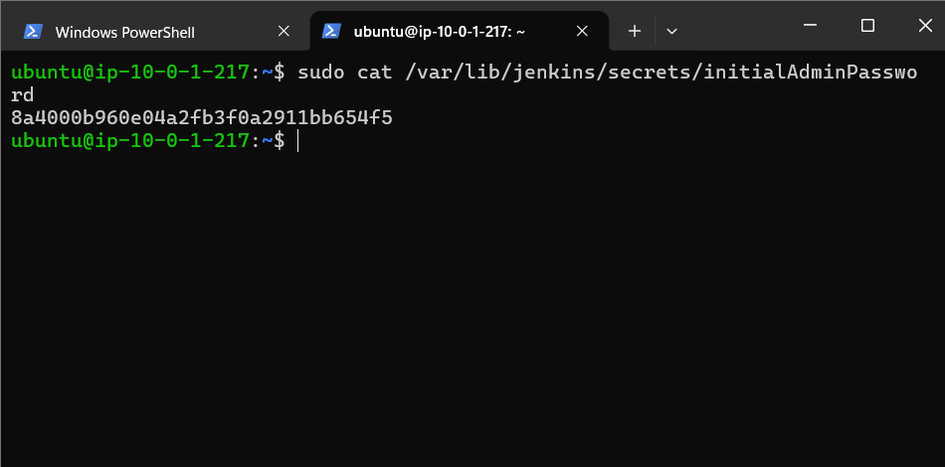

8a4000b960e04a2fb3f0a2911bb654f5

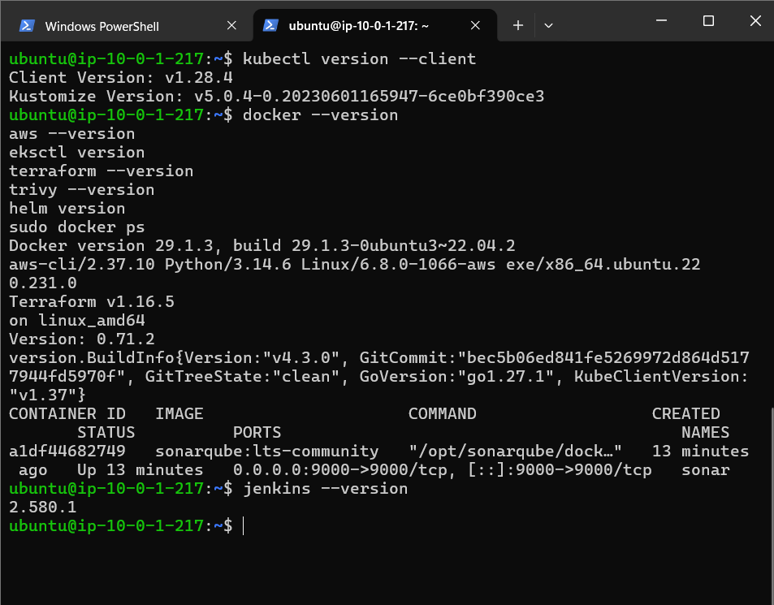

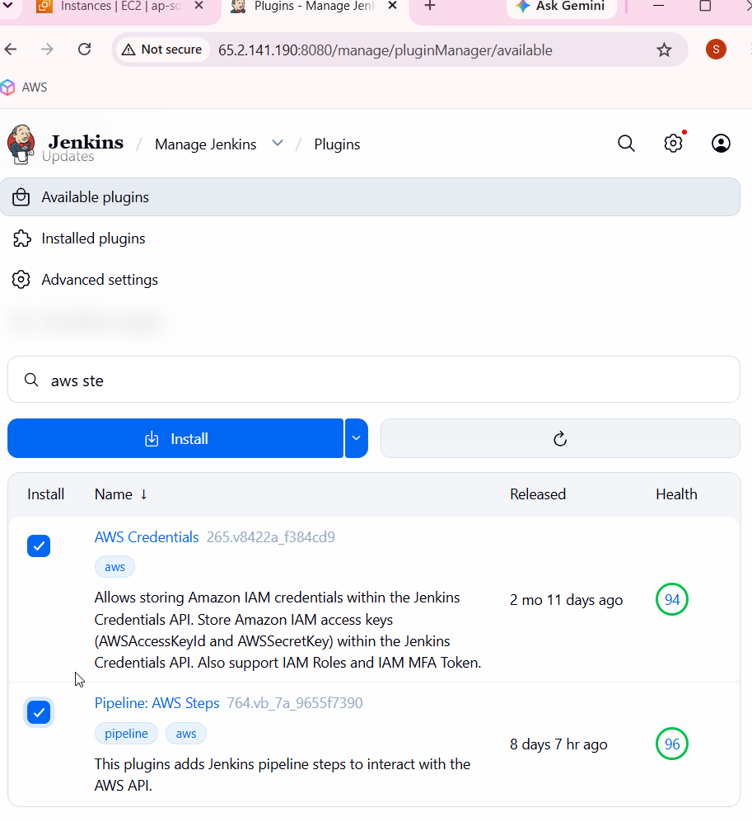

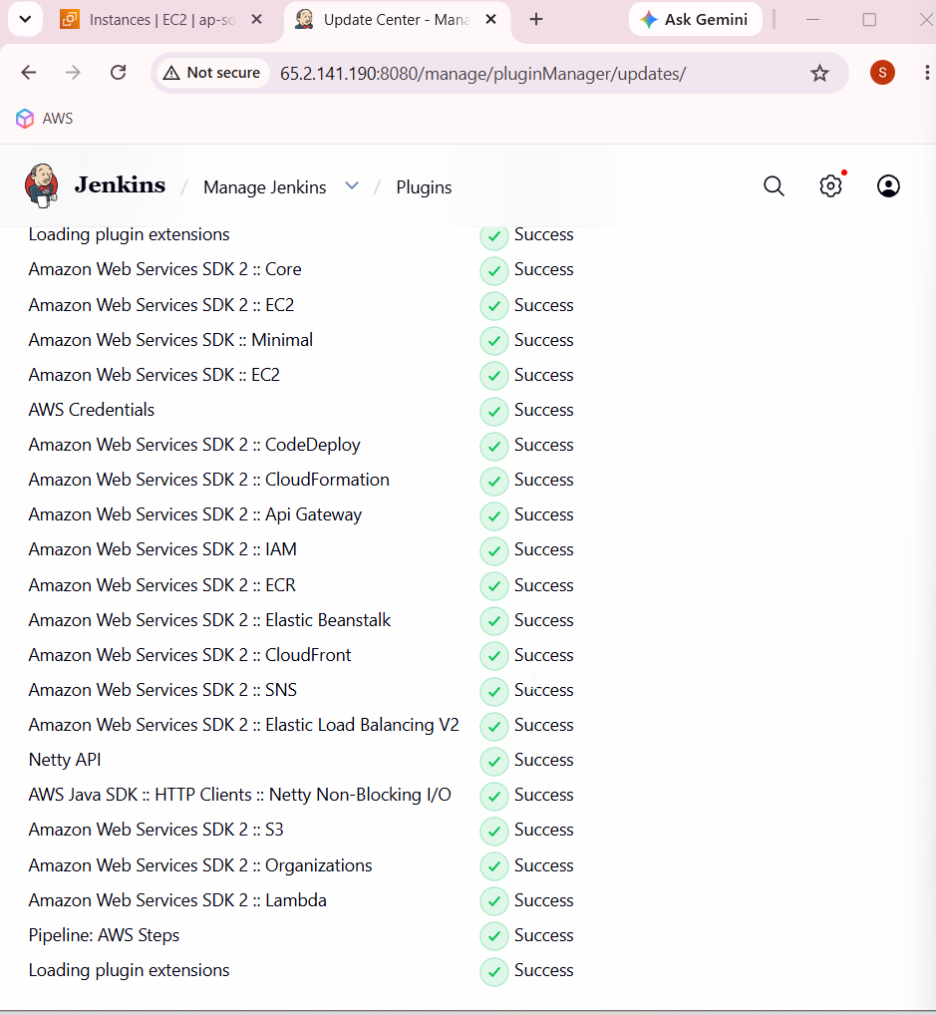

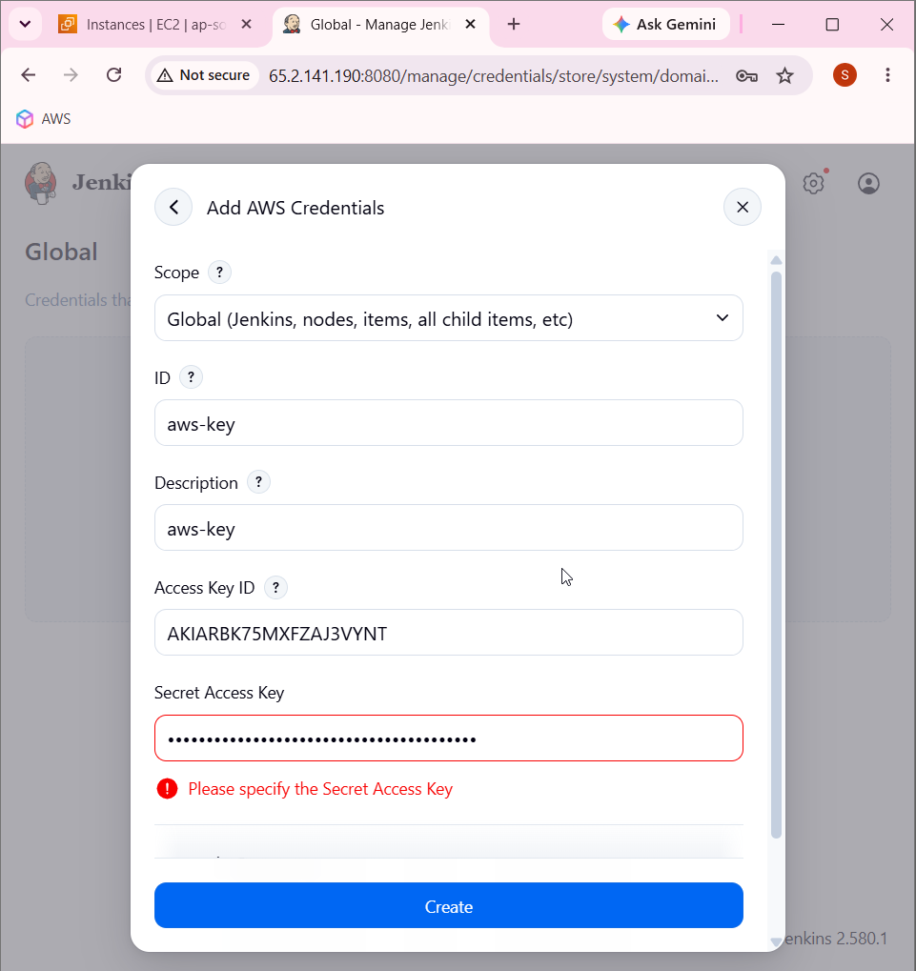

Create eks cluster

eksctl create cluster \
--name Three-Tier-K8s-EKS-Cluster \
--region ap-south-1 \
--node-type t2.medium \
--nodes-min 2 \
--nodes-max 2

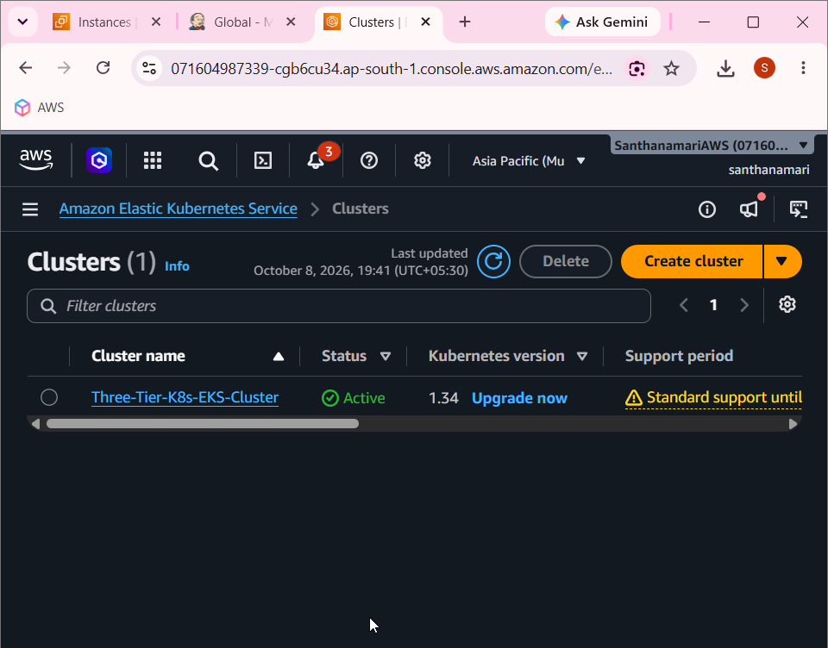

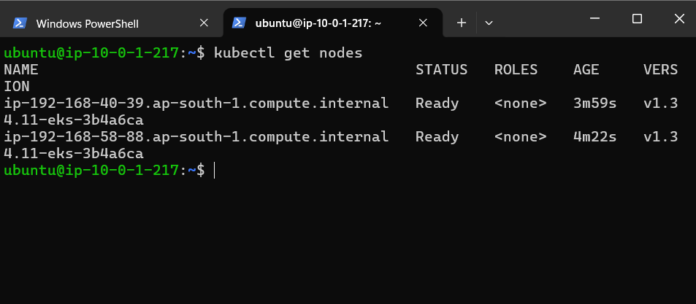

Download iam policy

curl -o iam_policy.json https://raw.githubusercontent.com/kubernetes-sigs/aws-load-balancer-controller/main/docs/install/iam_policy.json

aws iam create-policy-version \
--policy-arn arn:aws:iam::071604987339:policy/AWSLoadBalancerControllerIAMPolicy \
--policy-document file://iam_policy.json \
--set-as-default

Create oidc provider

eksctl utils associate-iam-oidc-provider --cluster Three-Tier-K8s-EKS-Cluster --region ap-south-1 --approve

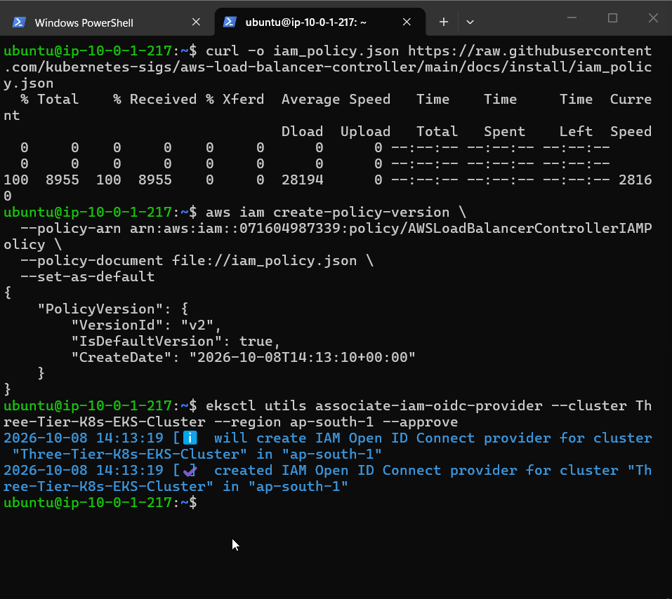

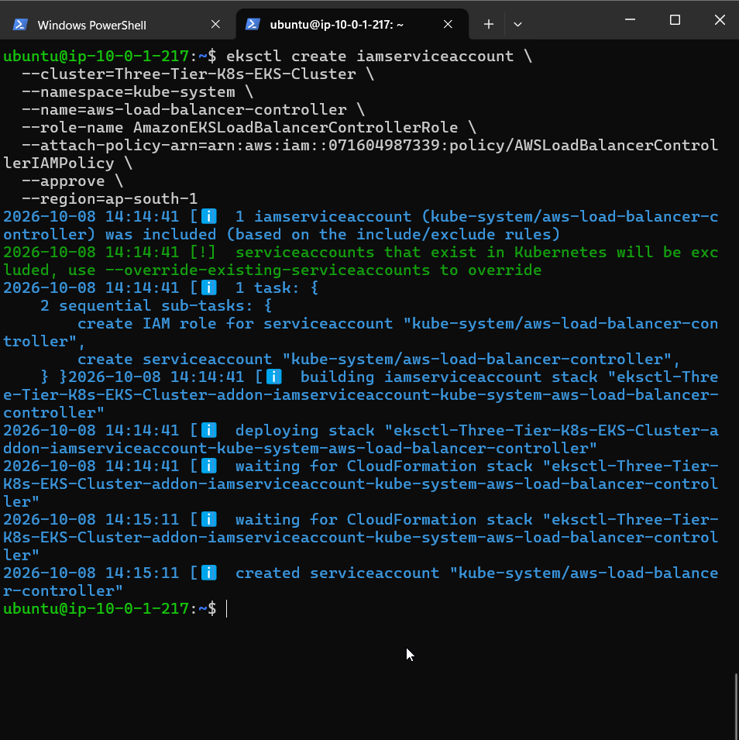

Create service account

eksctl create iamserviceaccount \
--cluster=Three-Tier-K8s-EKS-Cluster \
--namespace=kube-system \
--name=aws-load-balancer-controller \
--role-name AmazonEKSLoadBalancerControllerRole \
--attach-policy-arn=arn:aws:iam::071604987339:policy/AWSLoadBalancerControl
lerIAMPolicy \
--approve \
--region=ap-south-1

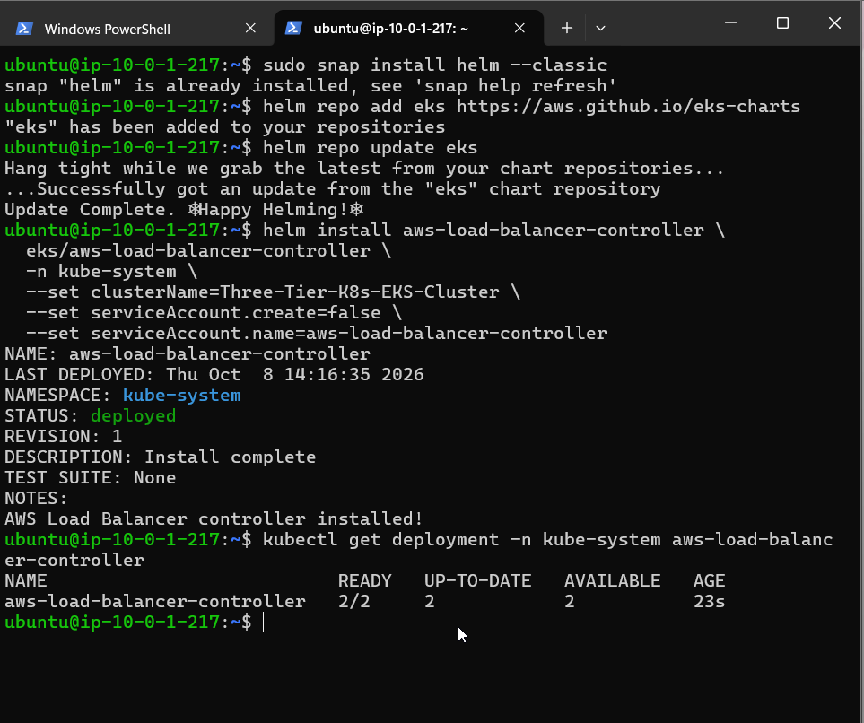

helm install aws-load-balancer-controller \
eks/aws-load-balancer-controller \
-n kube-system \
--set clusterName=Three-Tier-K8s-EKS-Cluster \
--set serviceAccount.create=false \
--set serviceAccount.name=aws-load-balancer-controller

kubectl get deployment -n kube-system aws-load-balancer-controller

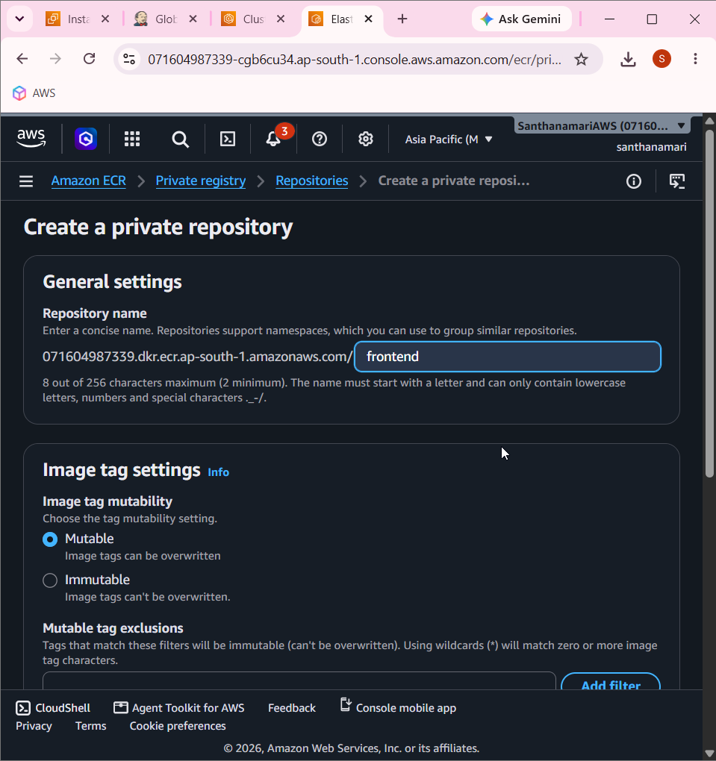

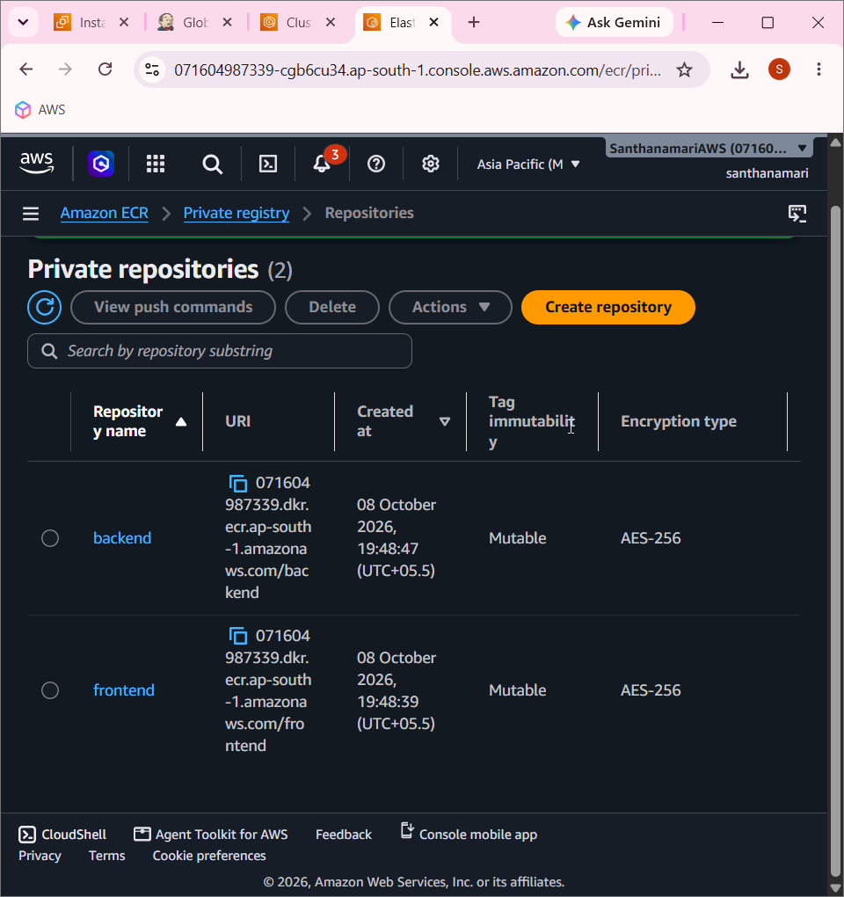

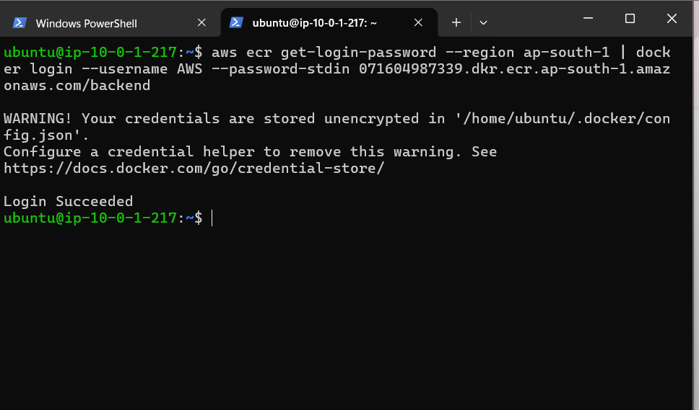

ws ecr get-login-password --region ap-south-1 | docker login --username AWS --password-stdin 071604987339.dkr.ecr.ap-south-1.amazonaws.com/backend

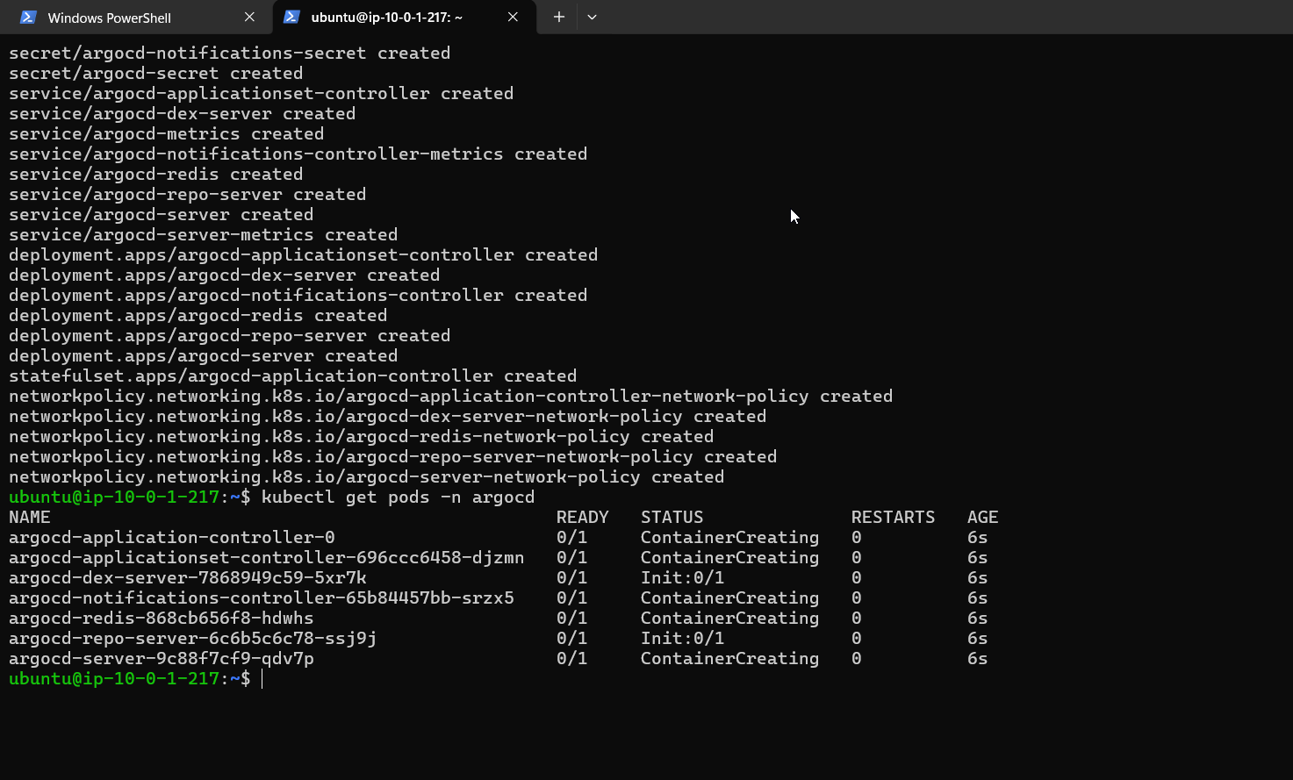

Install argocd

kubectl create namespace argocd
kubectl apply \
-n argocd \
-f https://raw.githubusercontent.com/argoproj/argo-cd/v2.4.7/manifests/install.yaml
kubectl get pods -n argocd

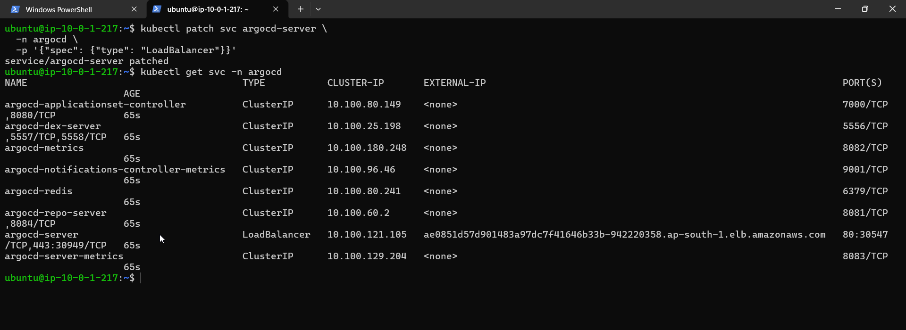

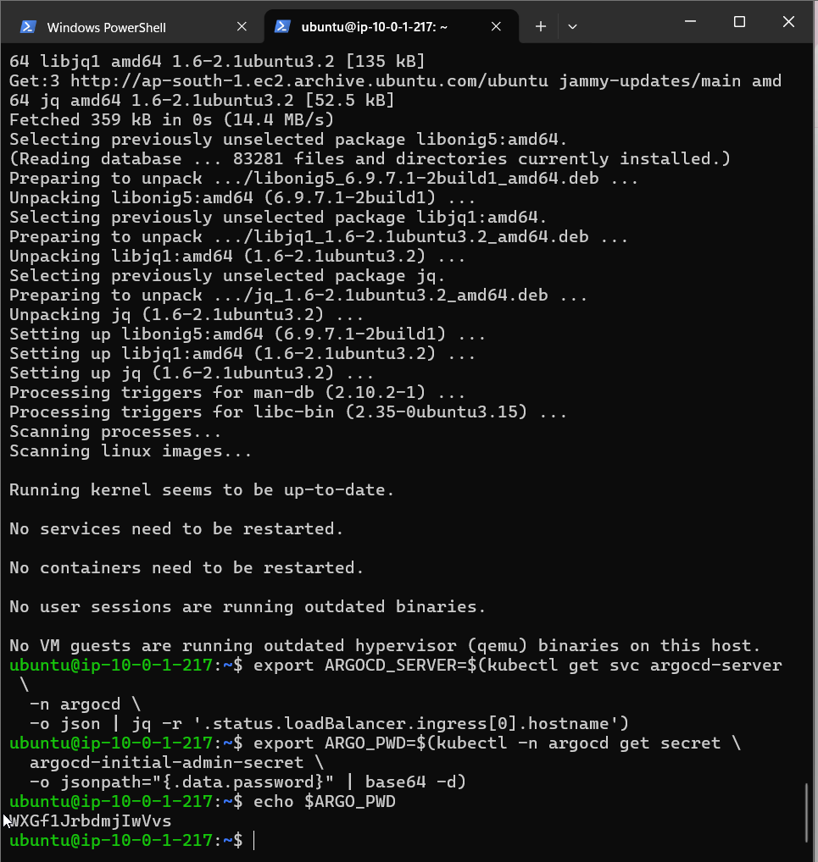

WXGf1JrbdmjIwVvs

Argocd pwd

sudo apt install jq -y

export ARGOCD_SERVER=$(kubectl get svc argocd-server \
-n argocd \
-o json | jq -r '.status.loadBalancer.ingress[0].hostname')
export ARGO_PWD=$(kubectl -n argocd get secret \
argocd-initial-admin-secret \
-o jsonpath="{.data.password}" | base64 -d)

echo $ARGO_PWD

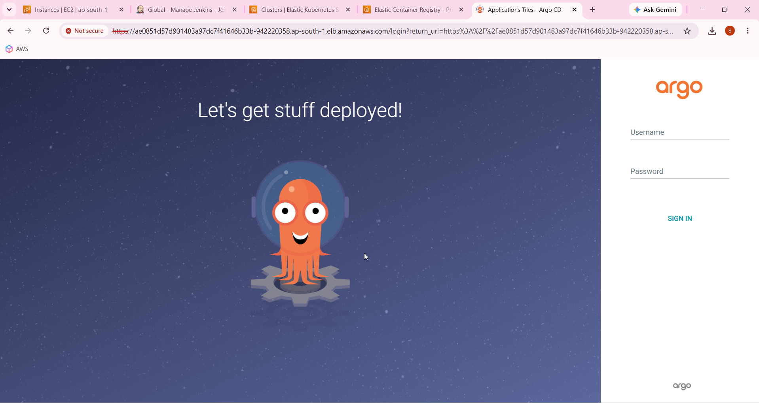

ae0851d57d901483a97dc7f41646b33b-942220358.ap-south-1.elb.amazonaws.com

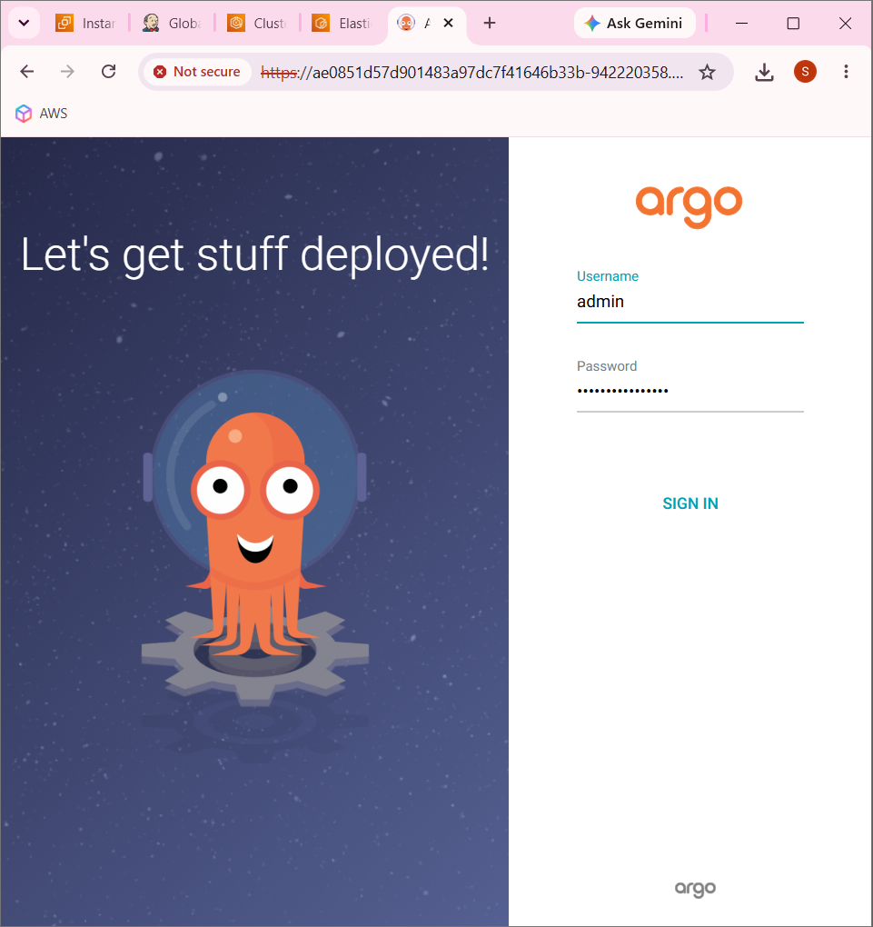

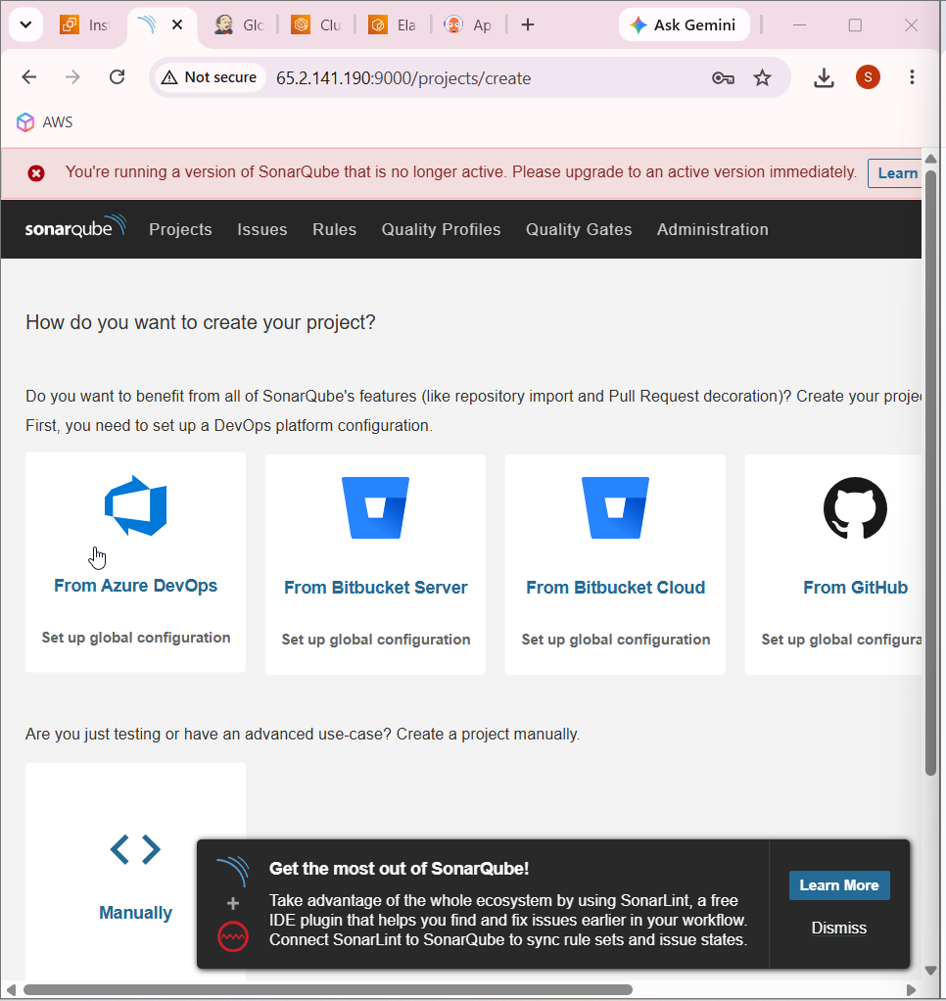
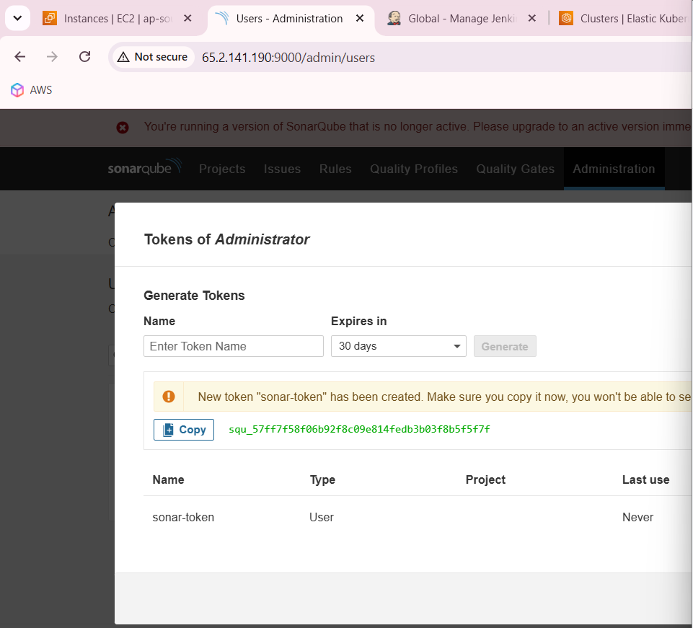

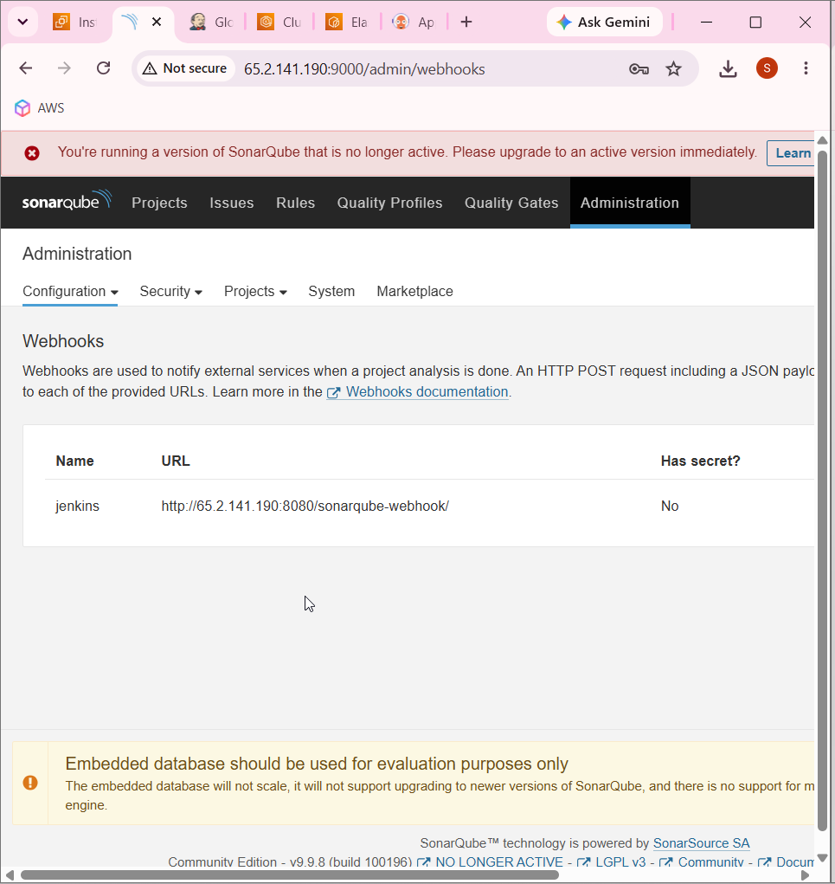

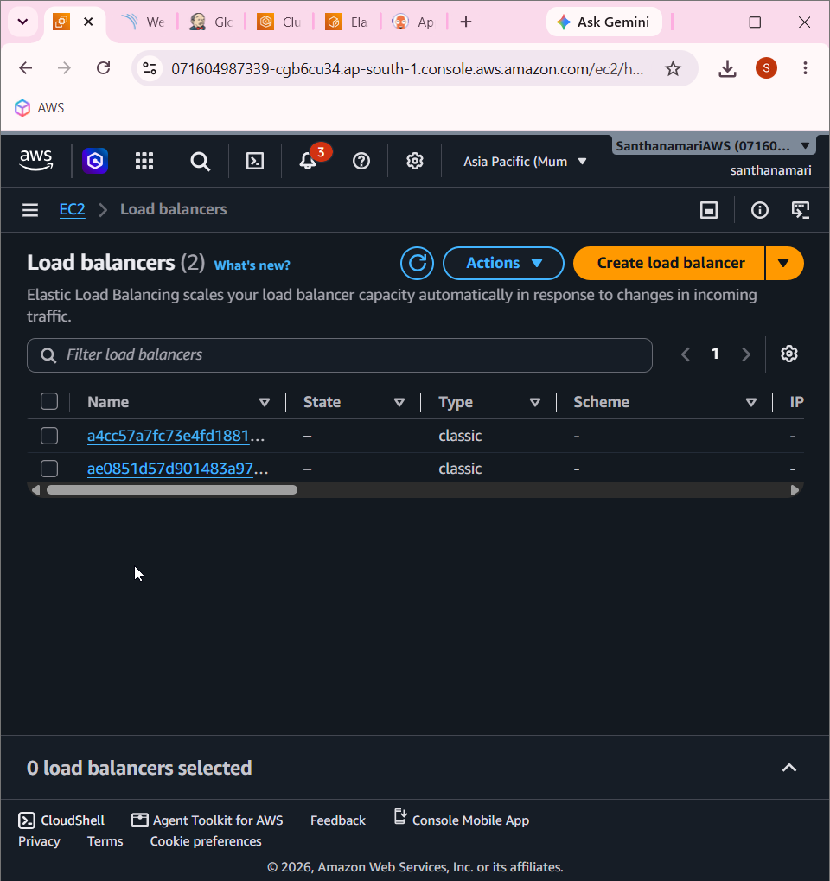

Load balancer

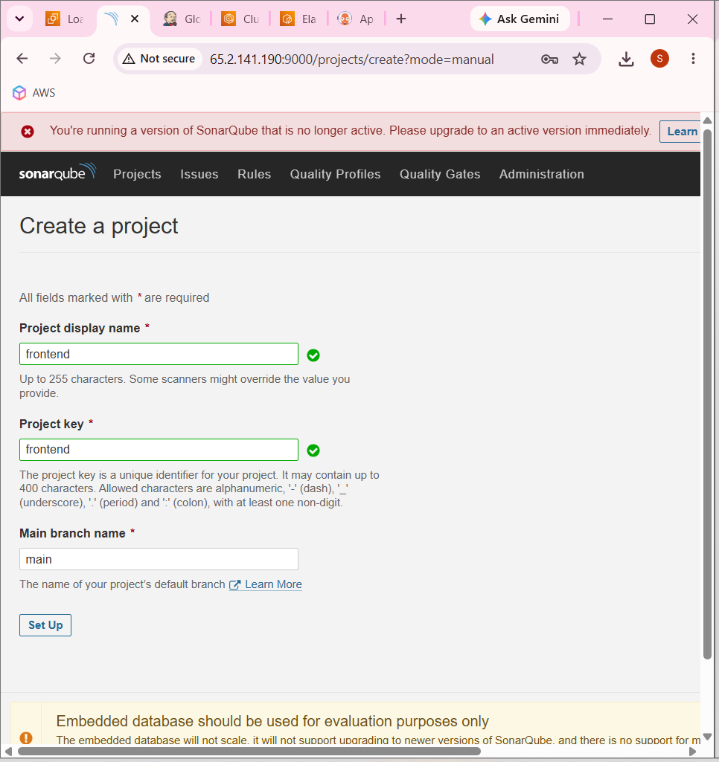

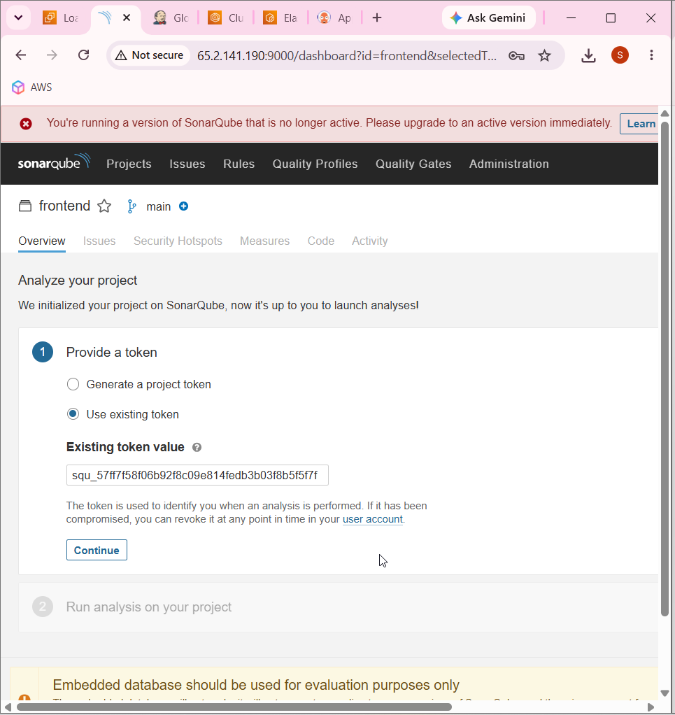

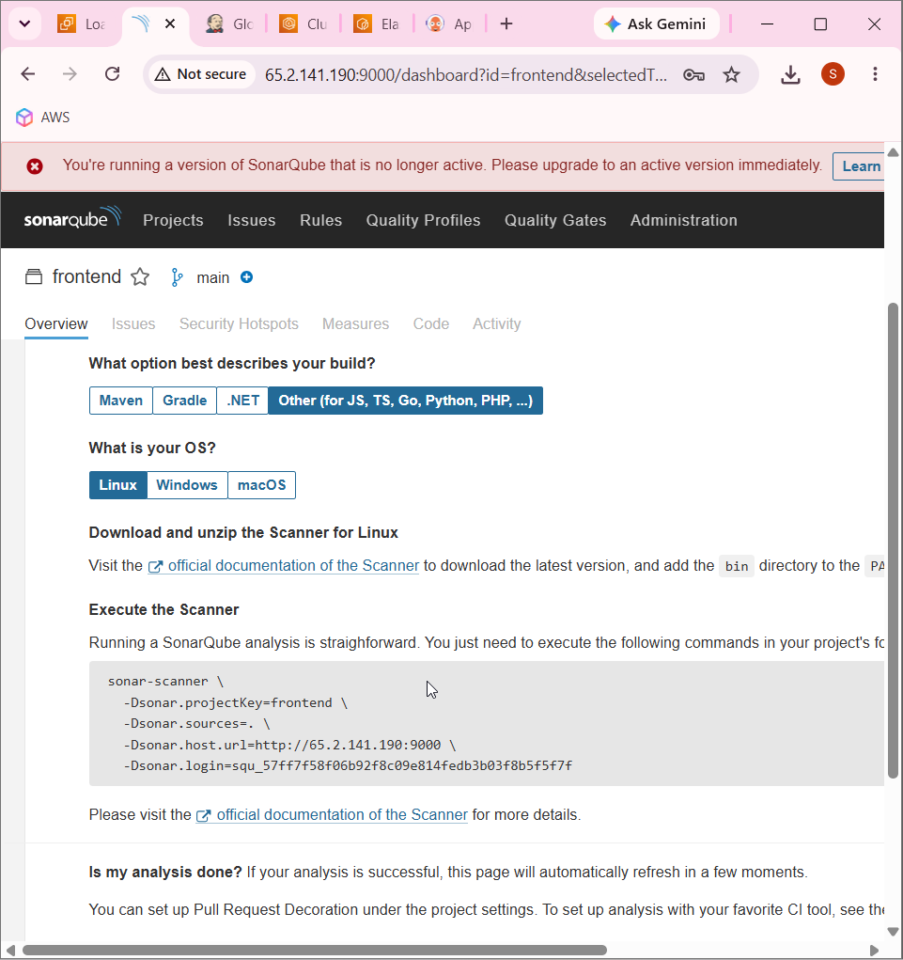

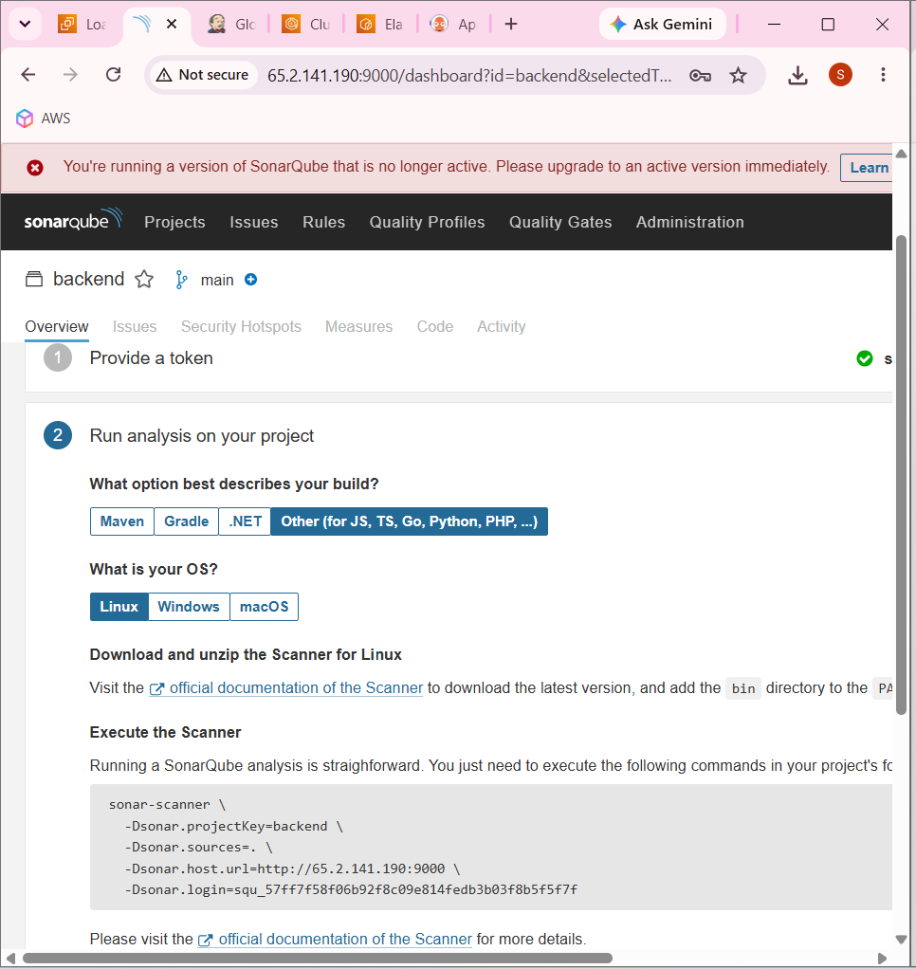

Backend

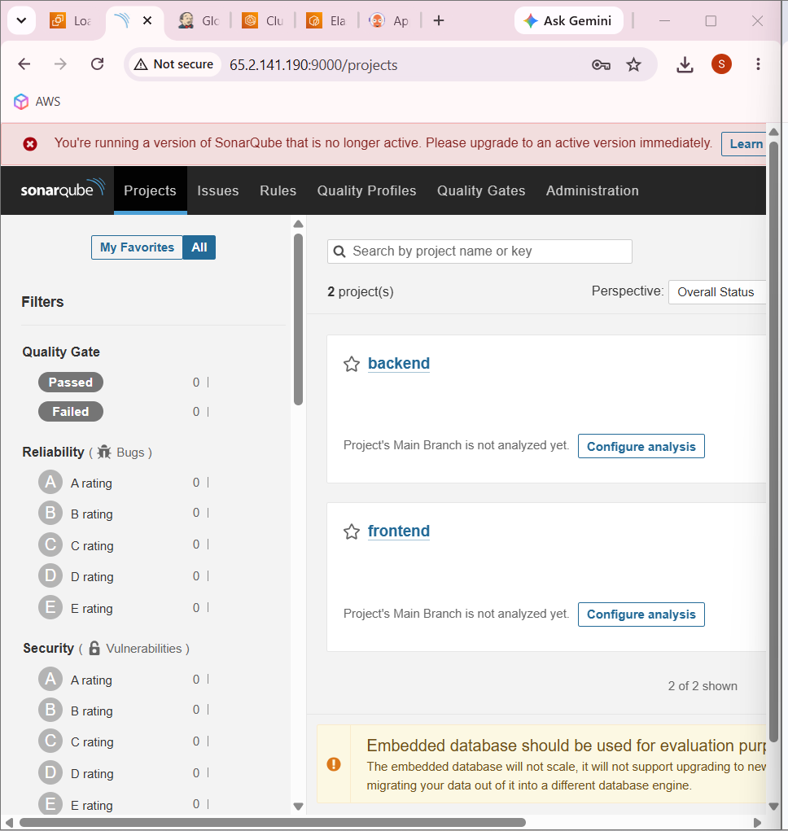

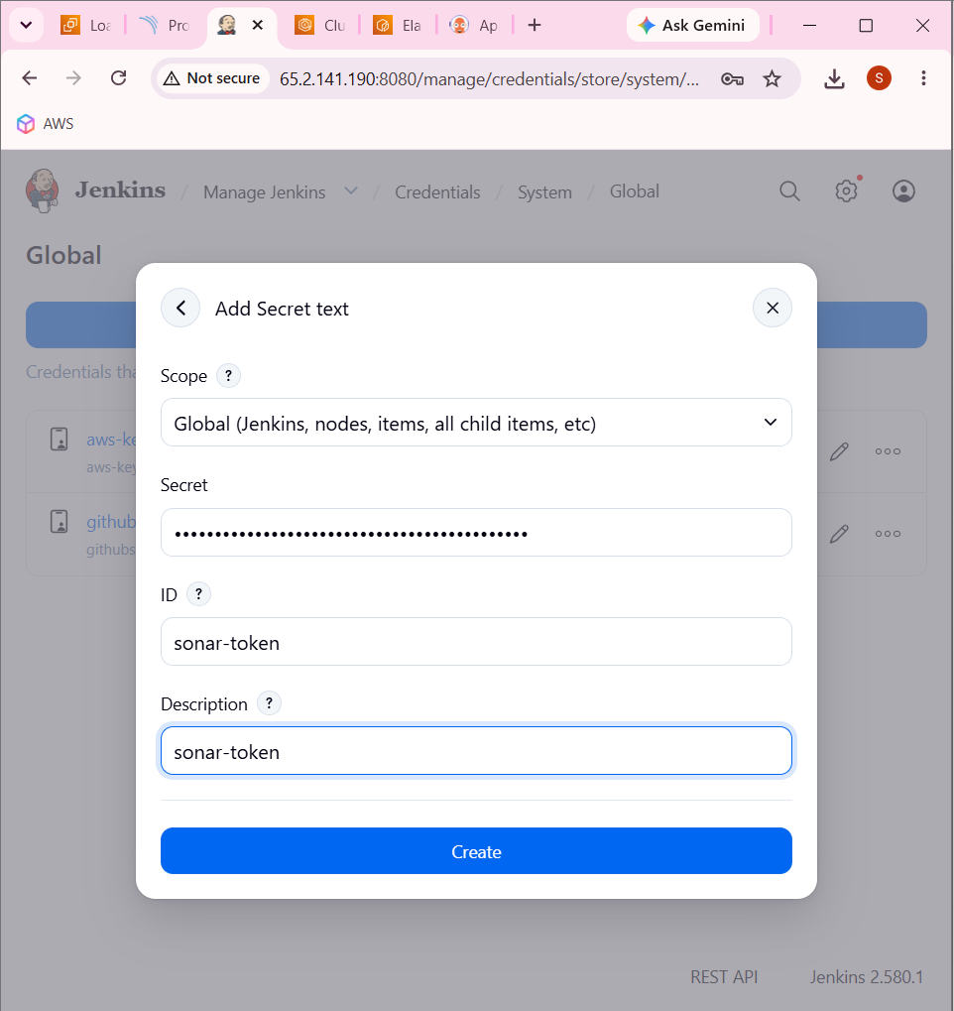

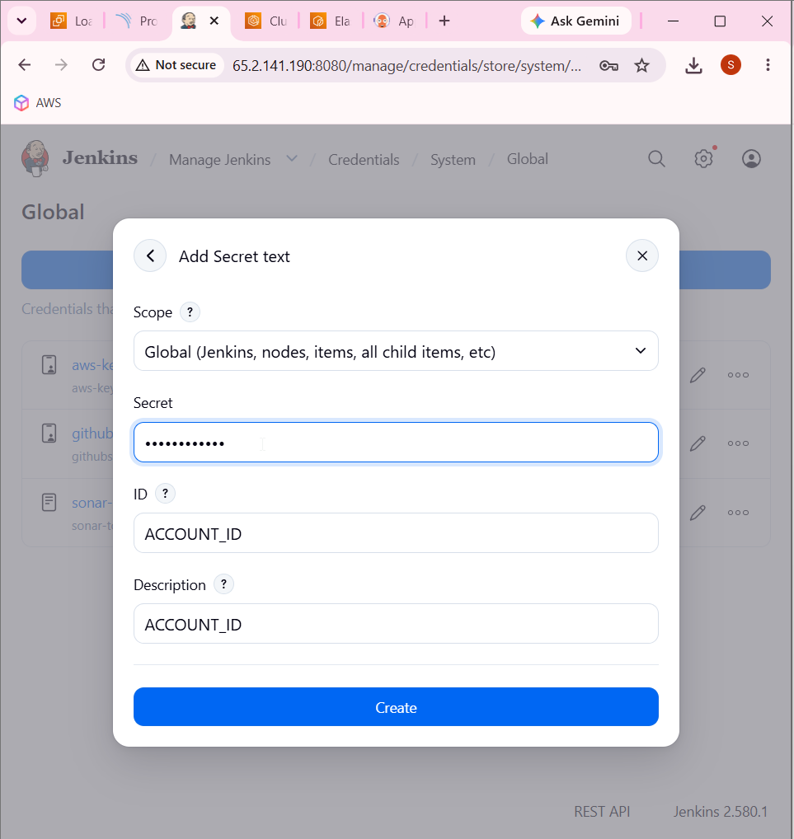

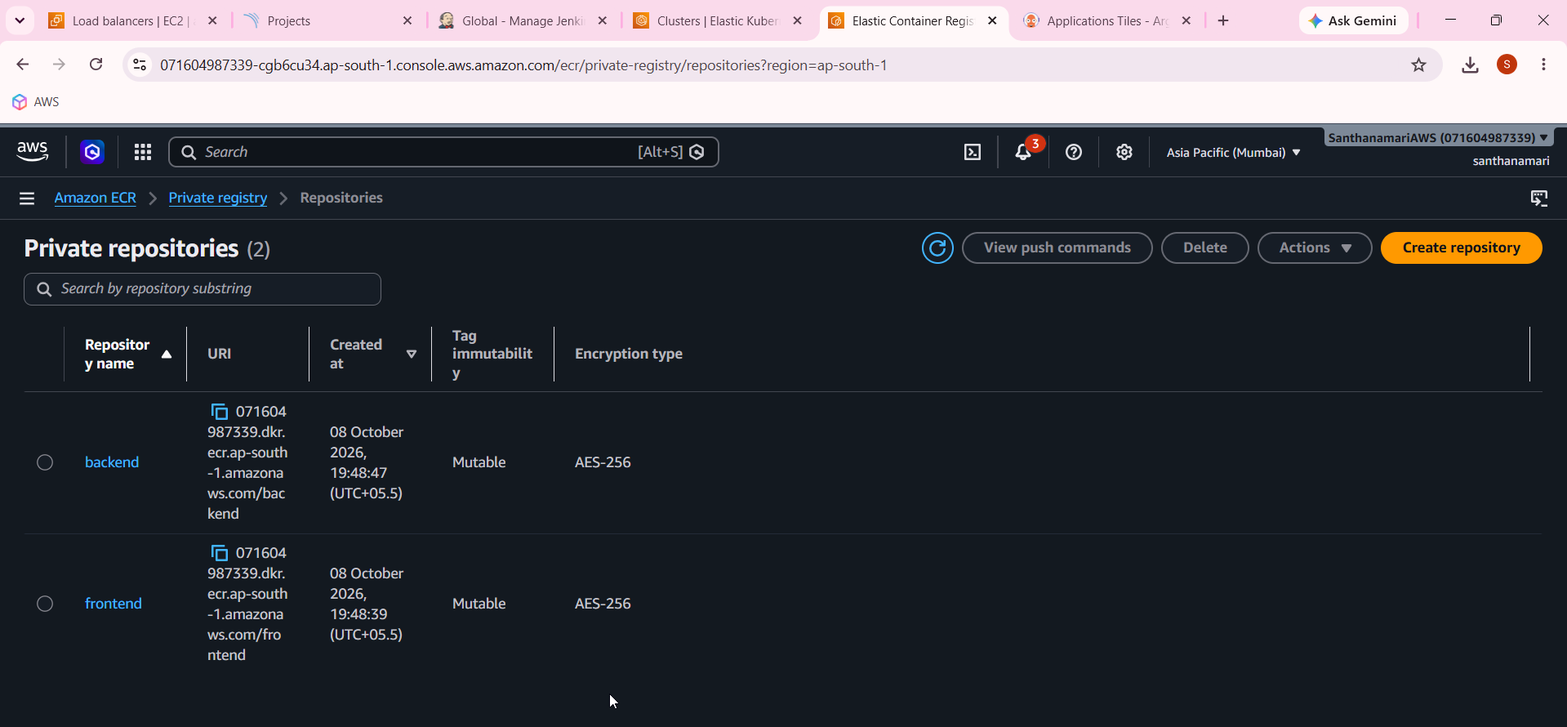
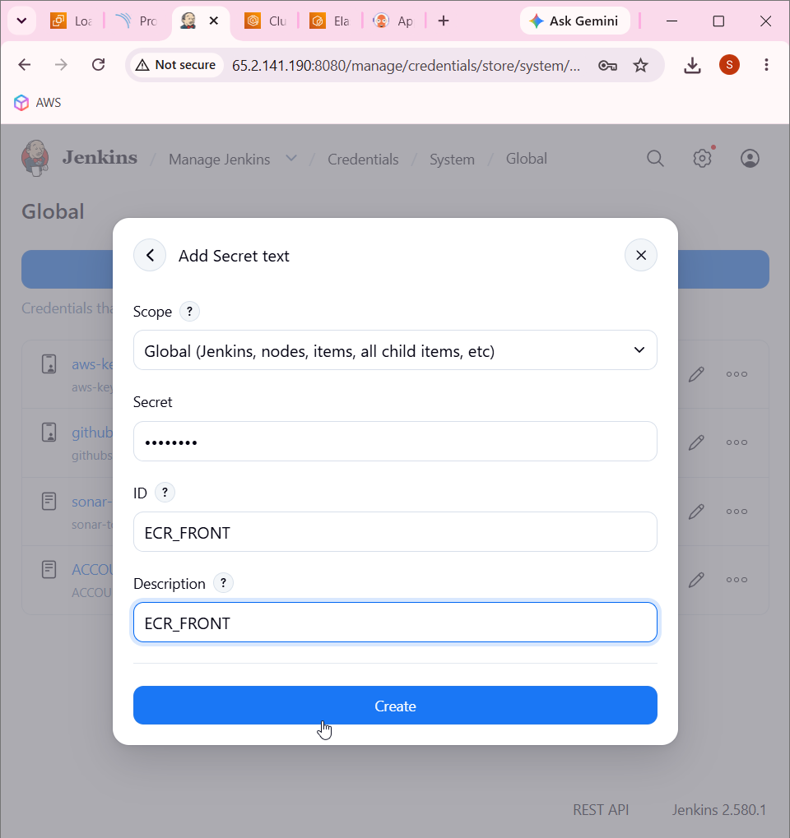

SECRET is backend and frontend

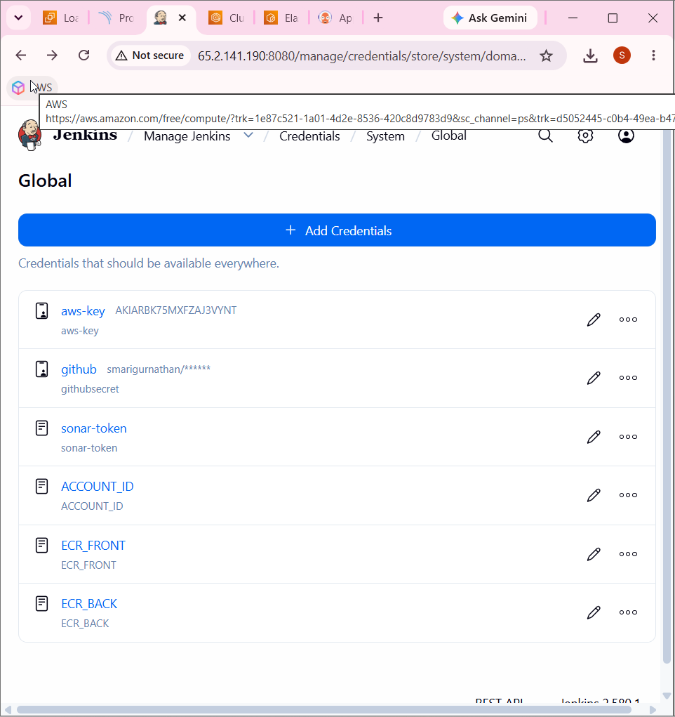

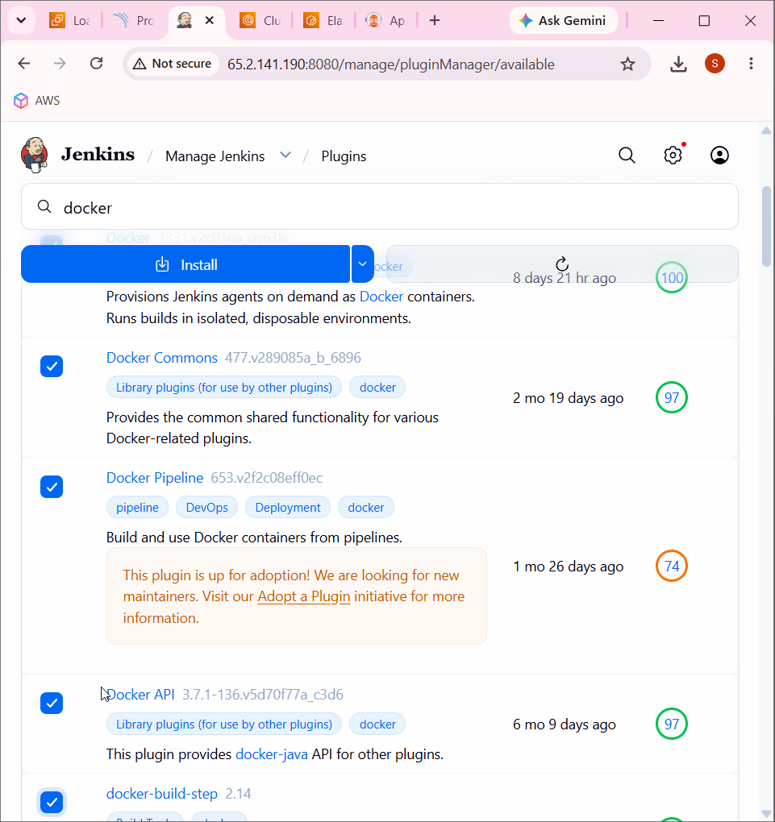

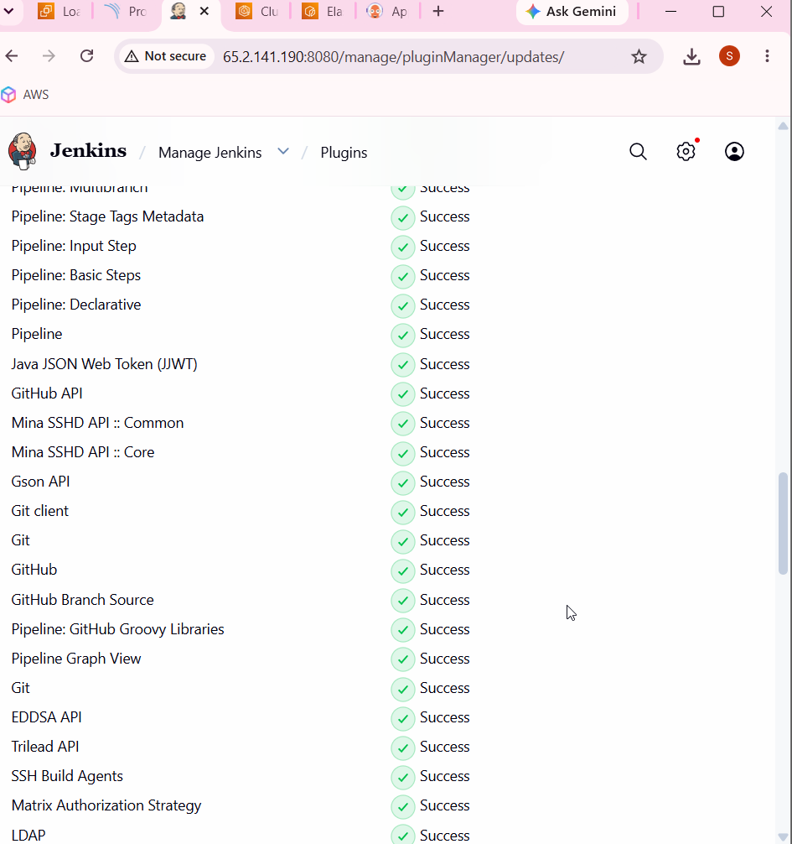

Docker
Docker commons
Docker pipeline
Docker api
Docker-build-api
Eclipse temurin installer
Nodejs
Owasp dependency-check
Sonarqube scanner

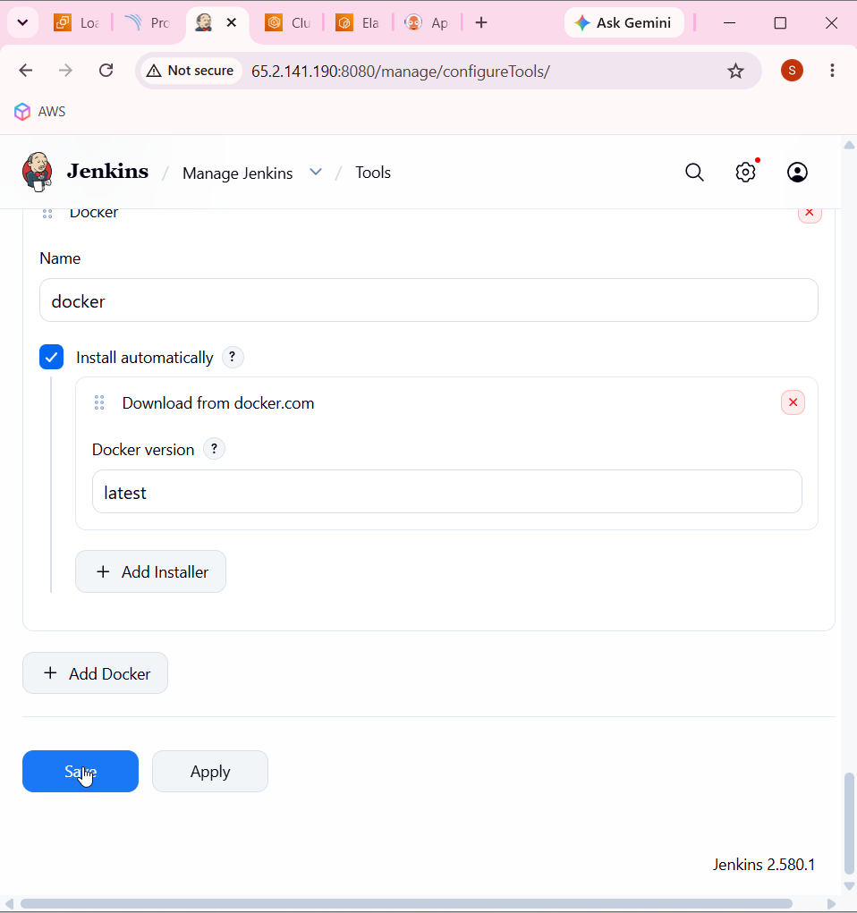

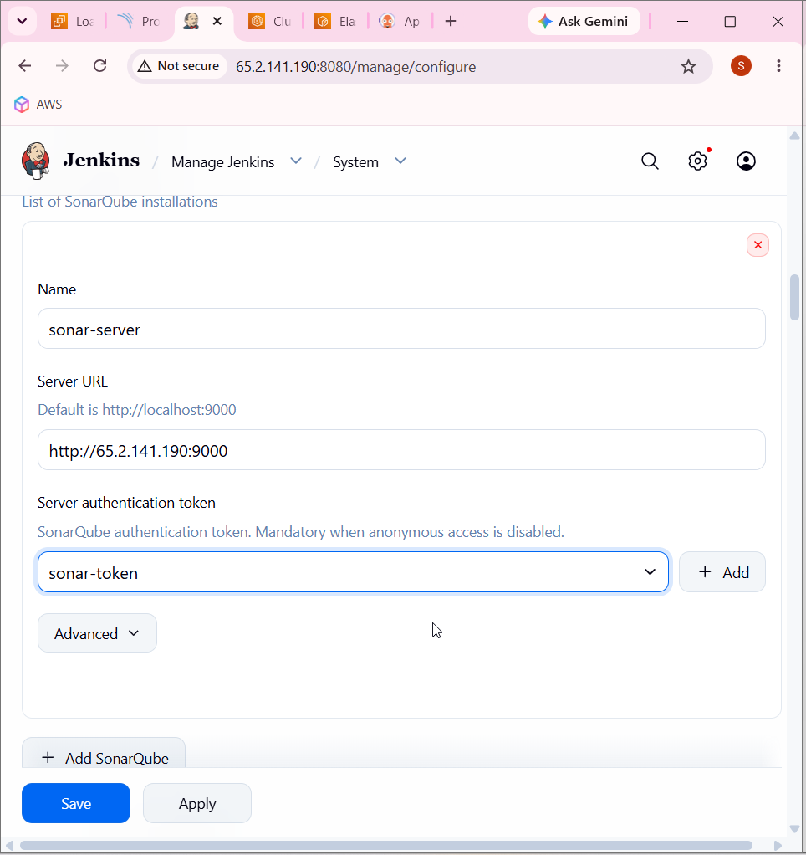

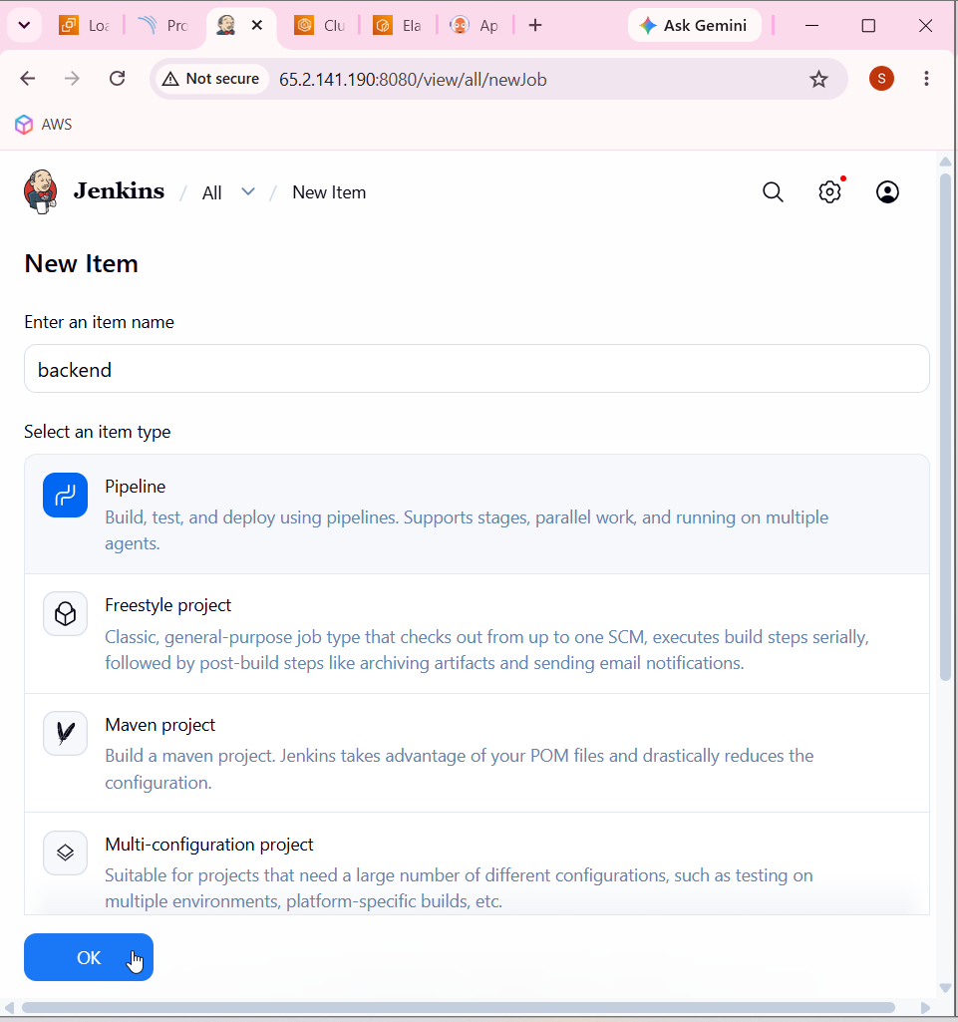

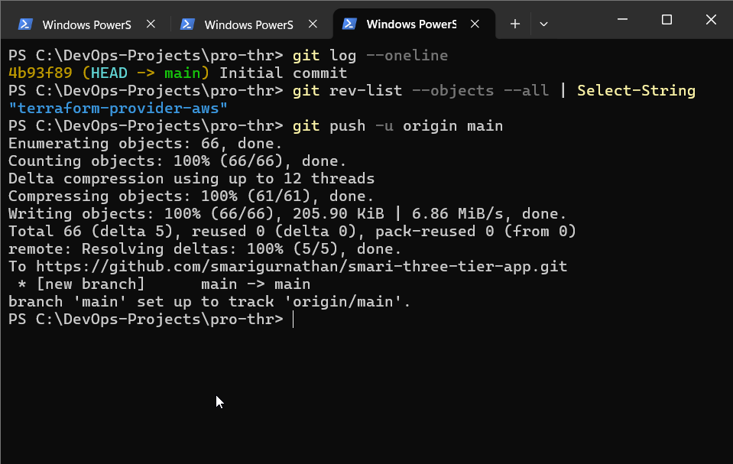

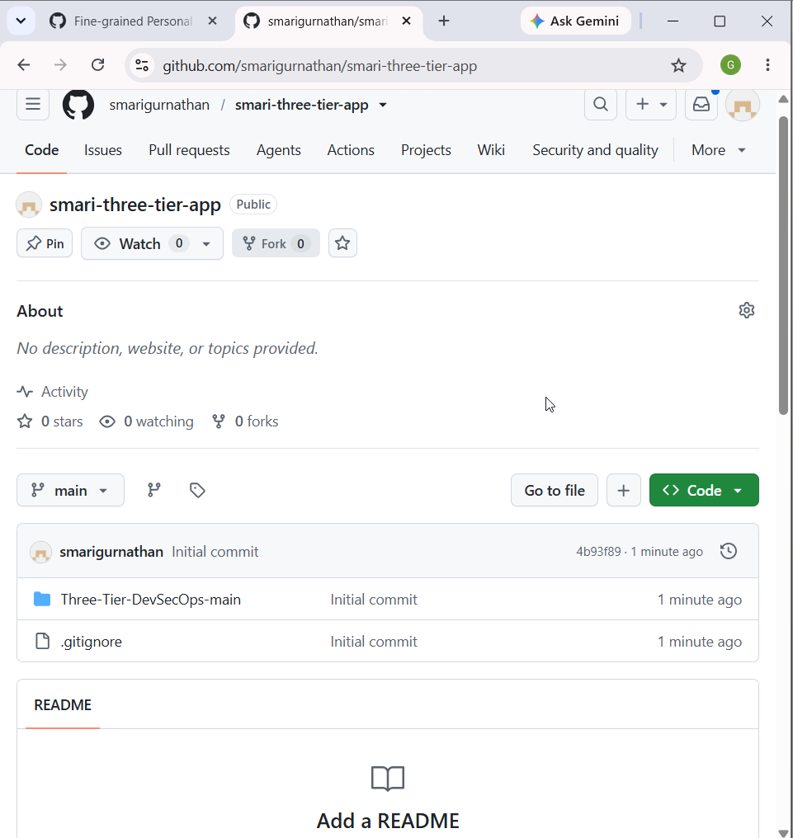

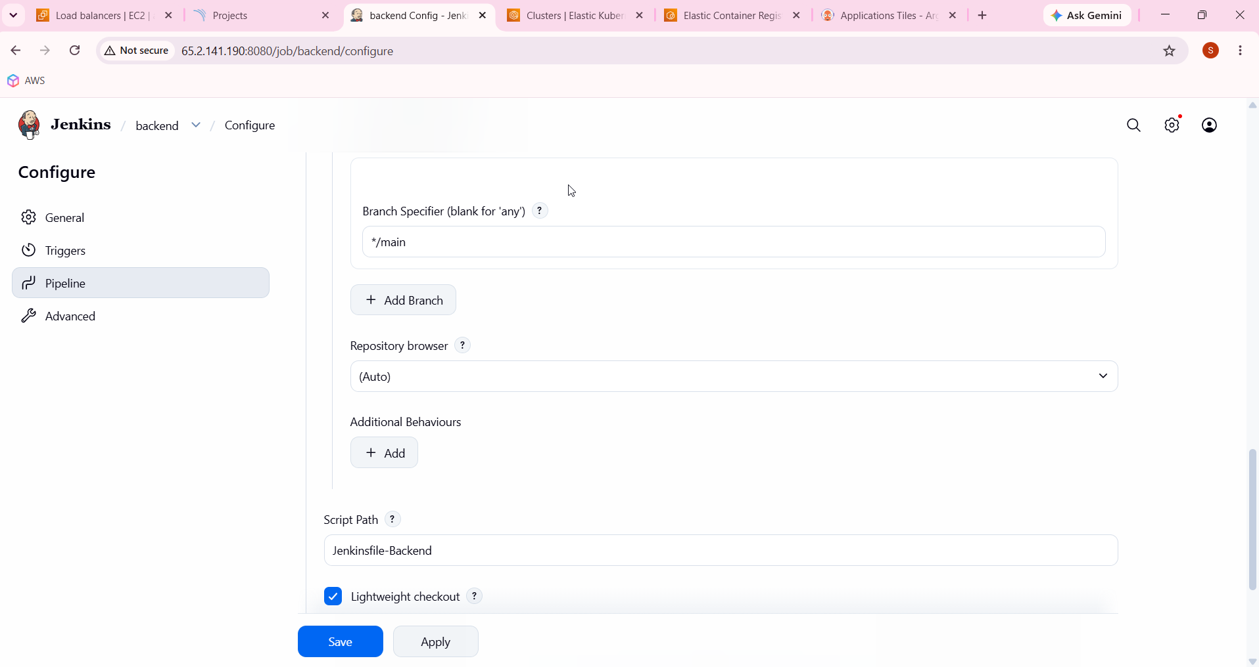

https://github.com/smarigurnathan/smari-three-tier-app.git

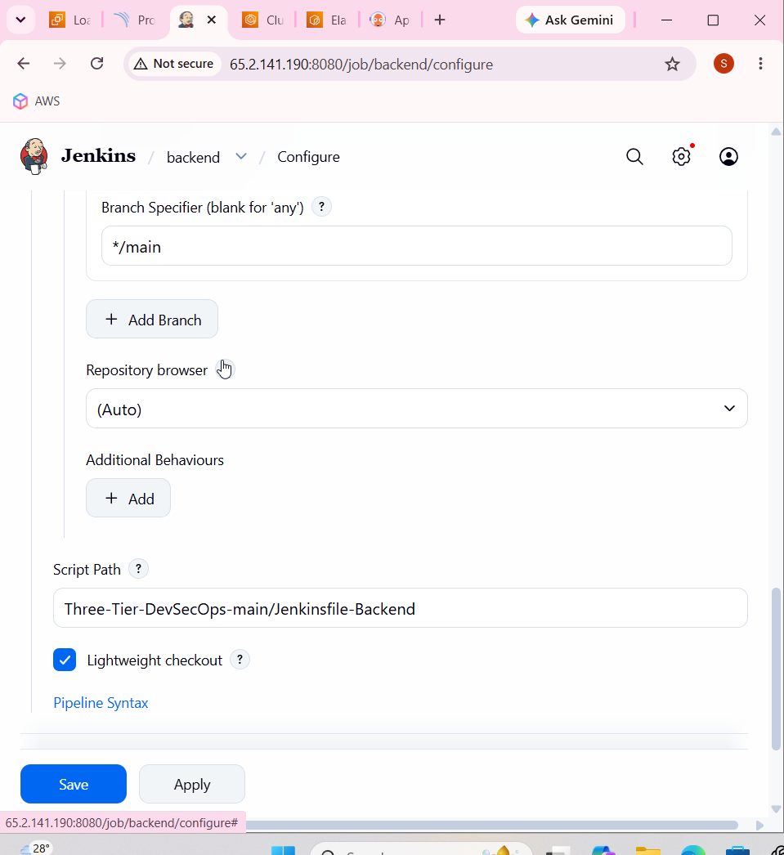

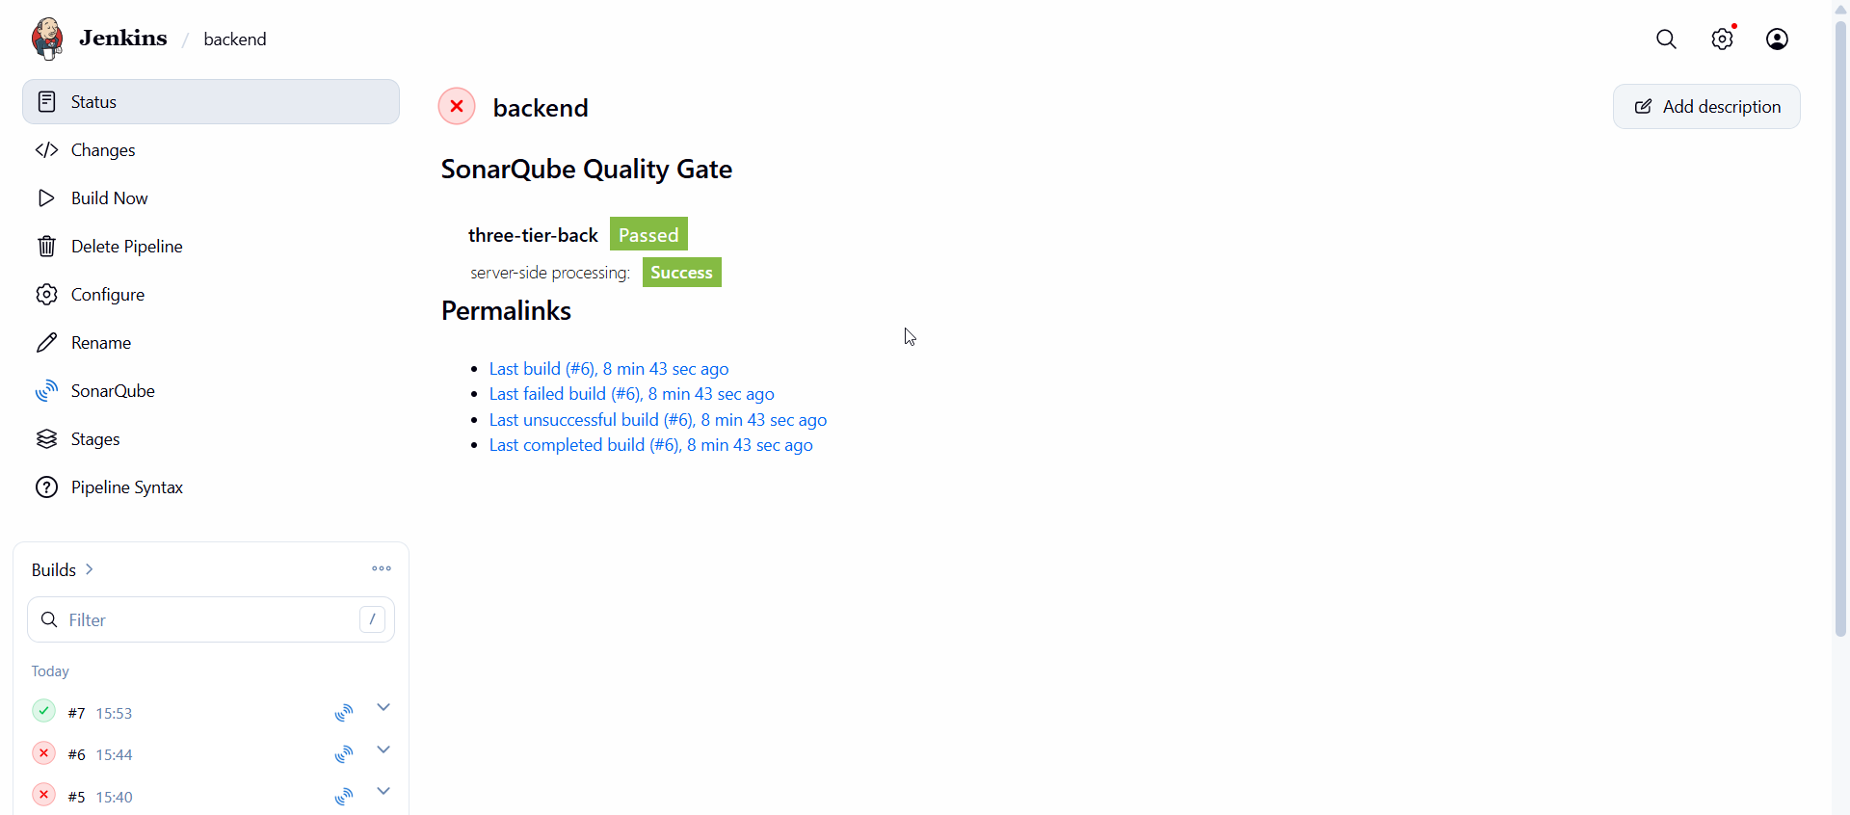

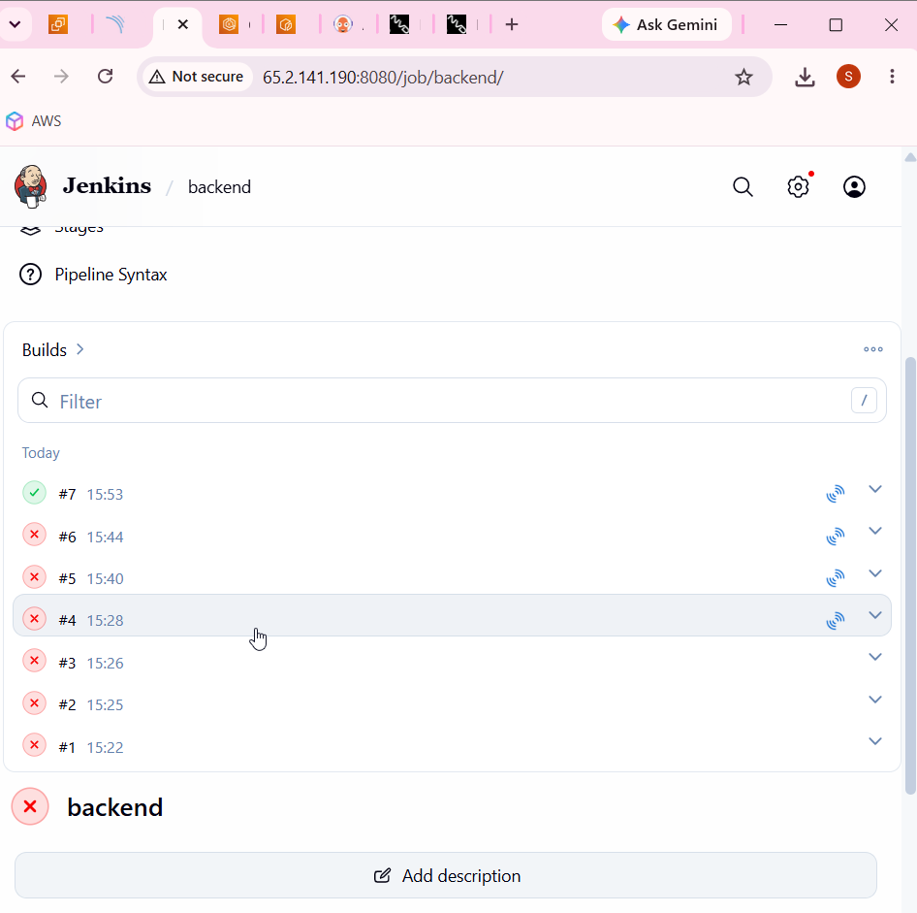

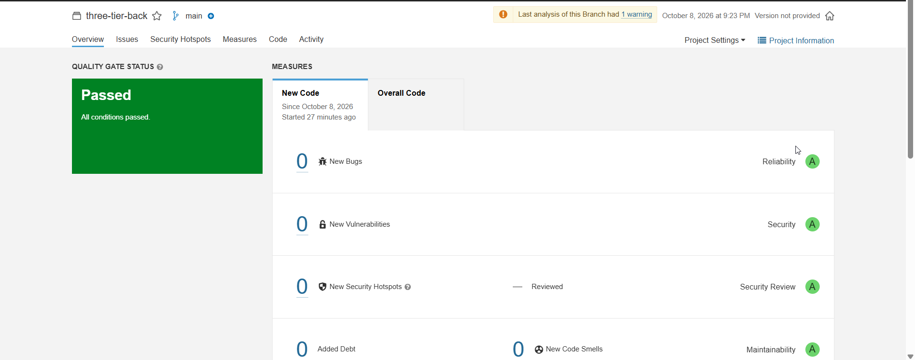

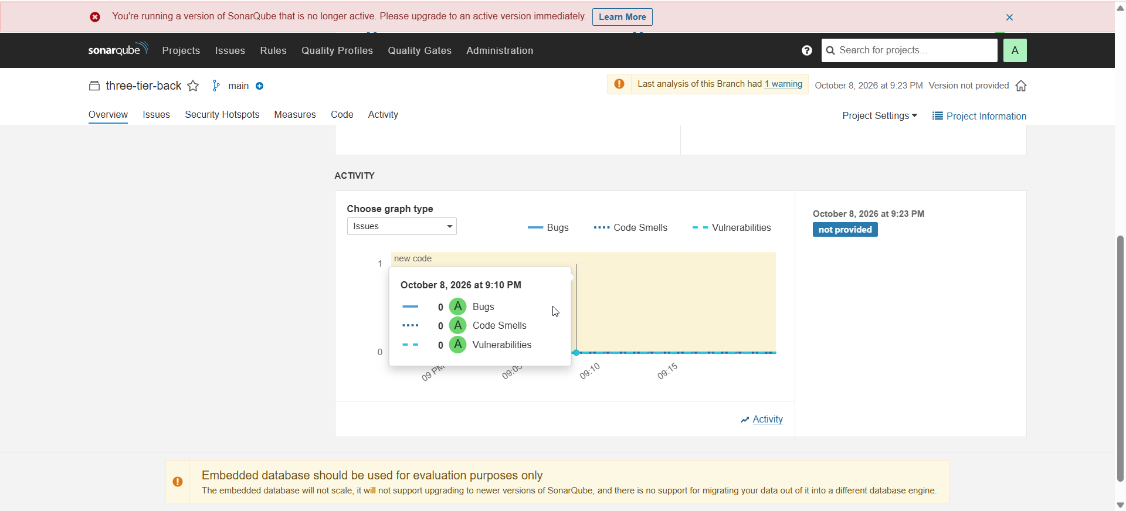

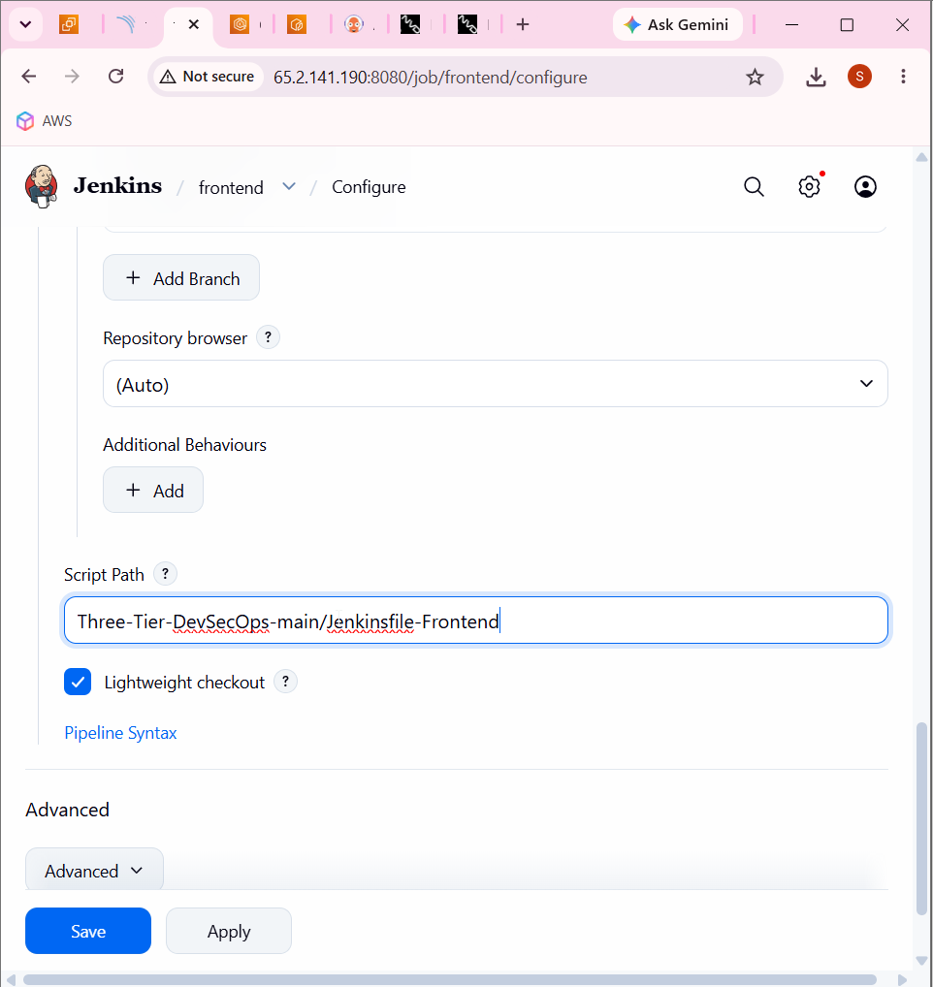

Frontend

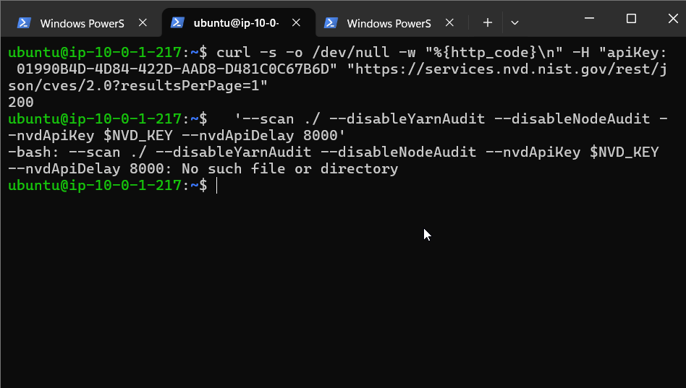

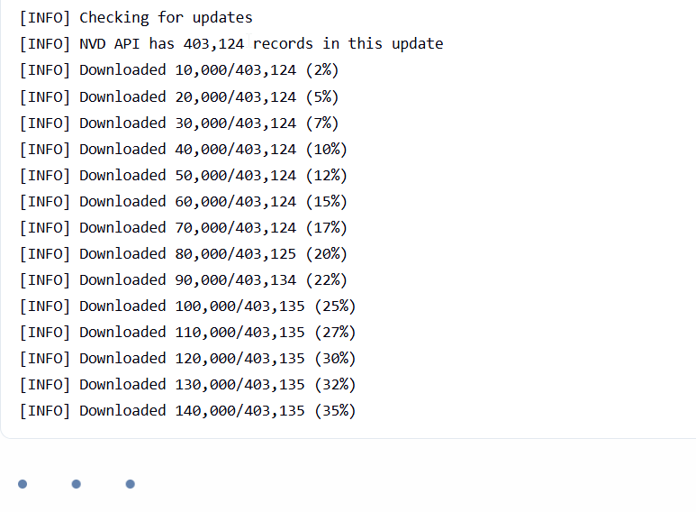

The security database is being updated.

The program is downloading security/vulnerability information from the NVD database.

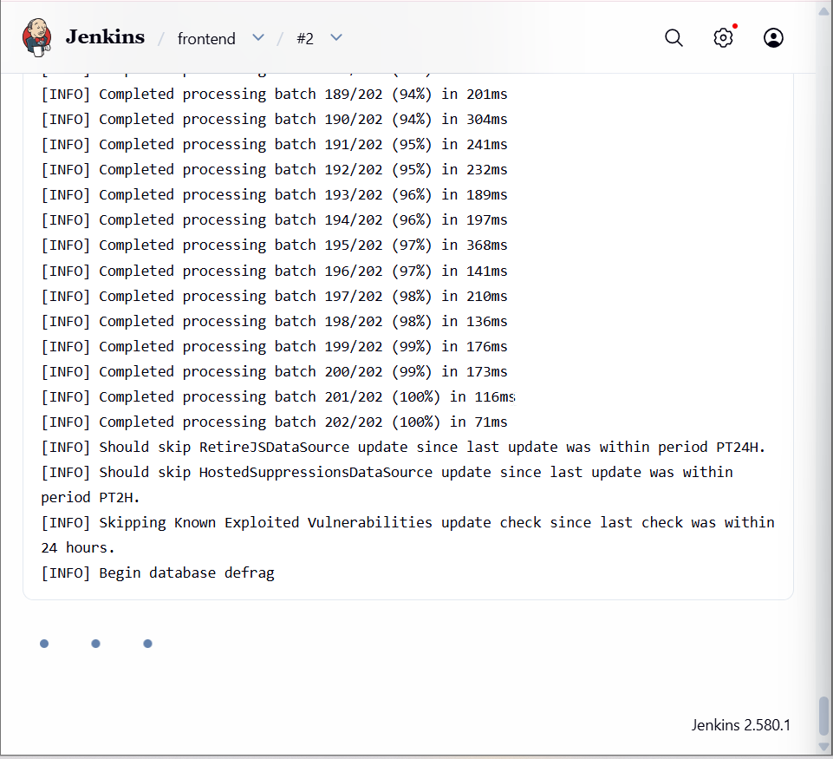

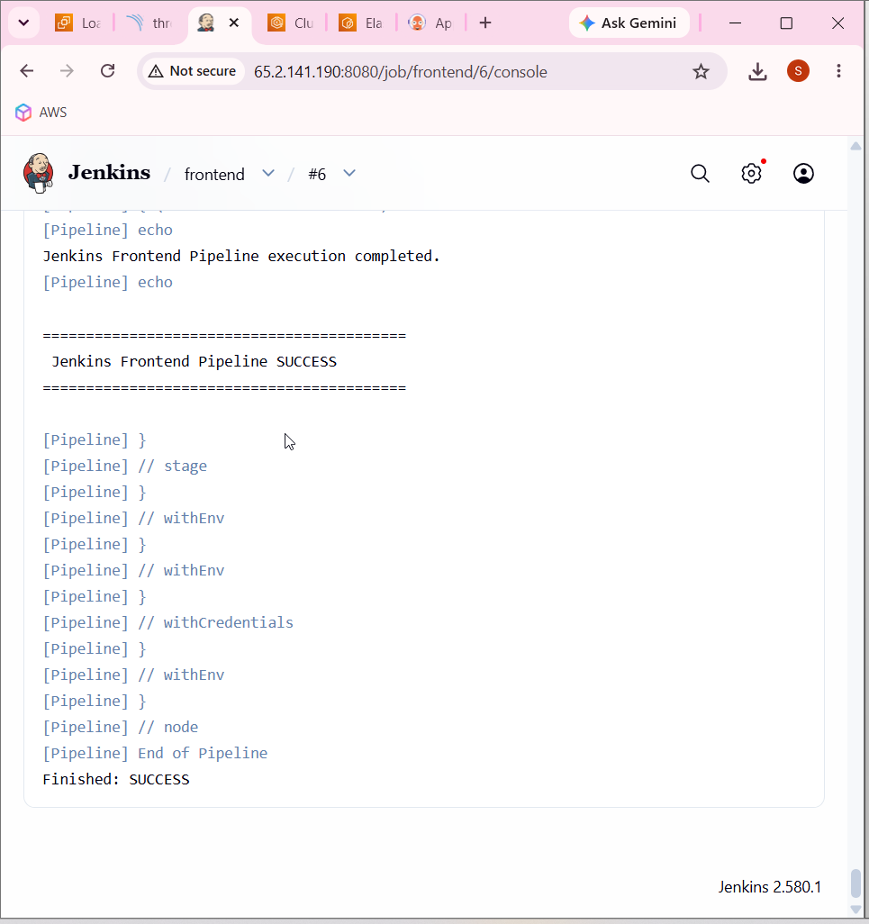

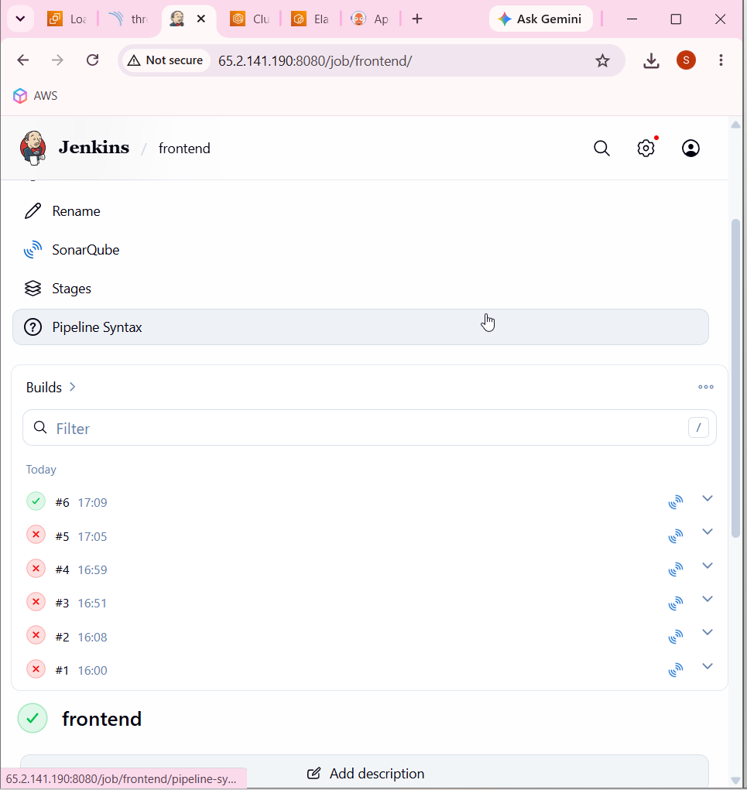

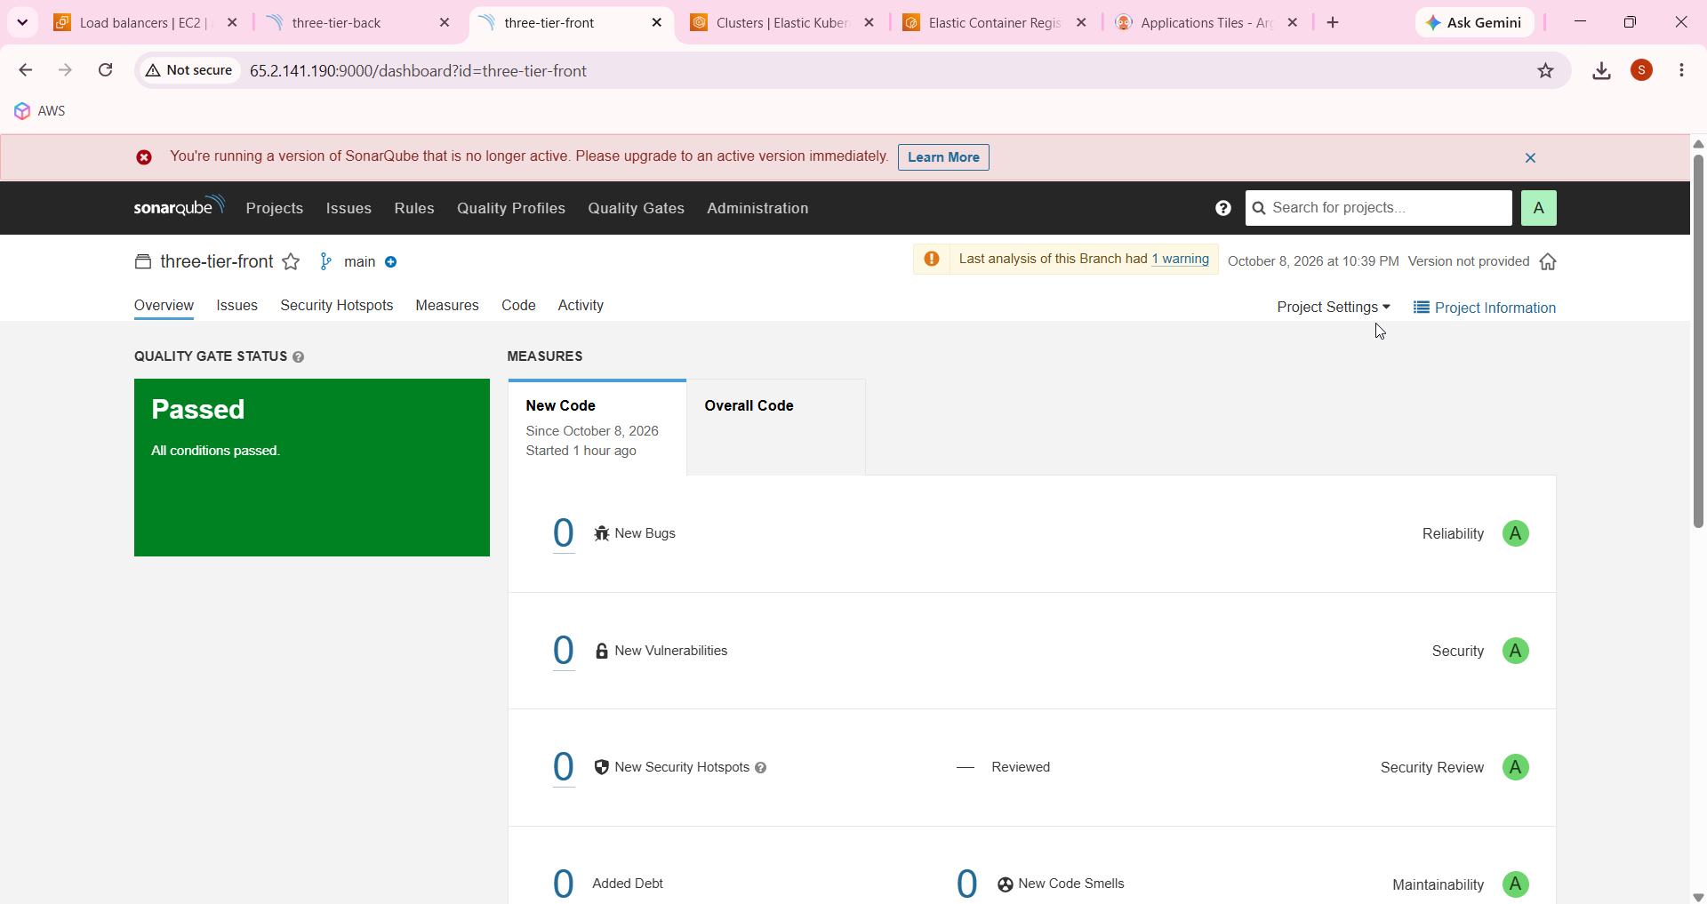

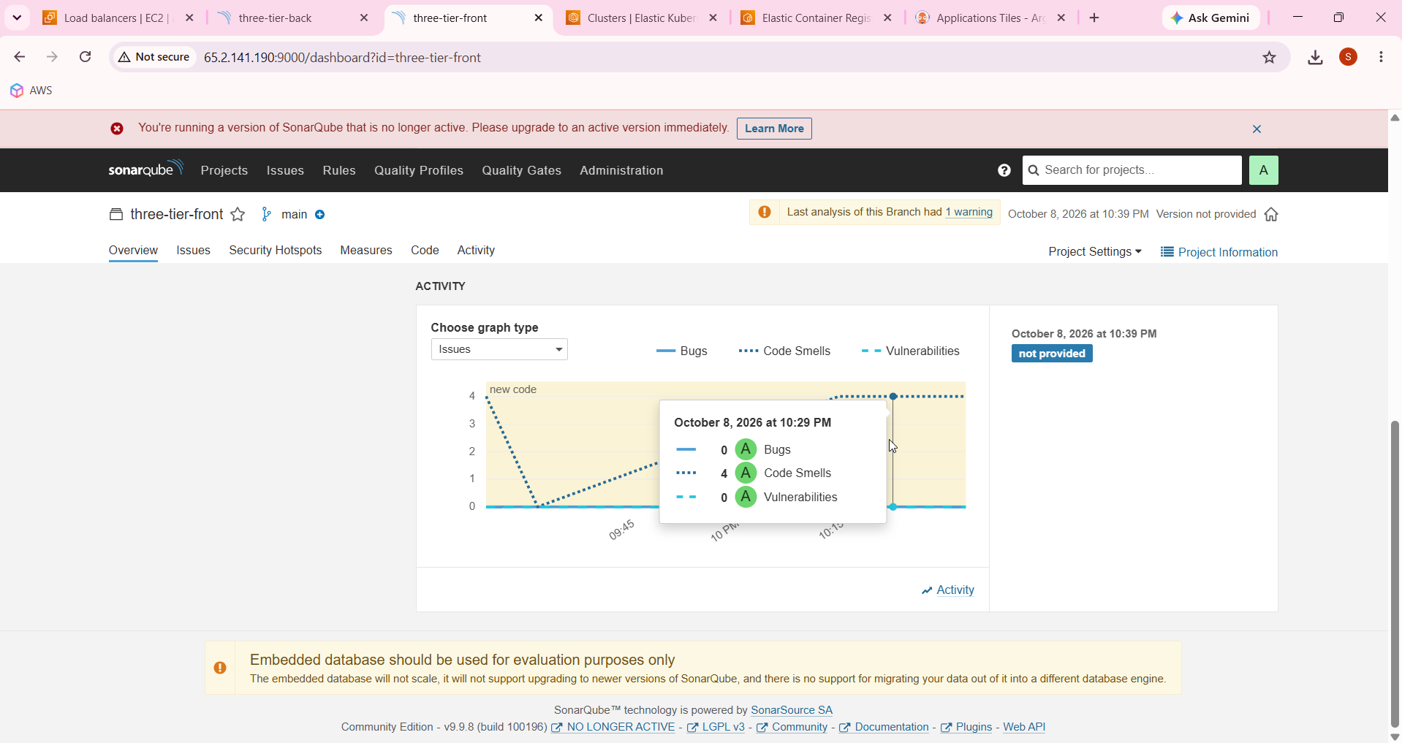

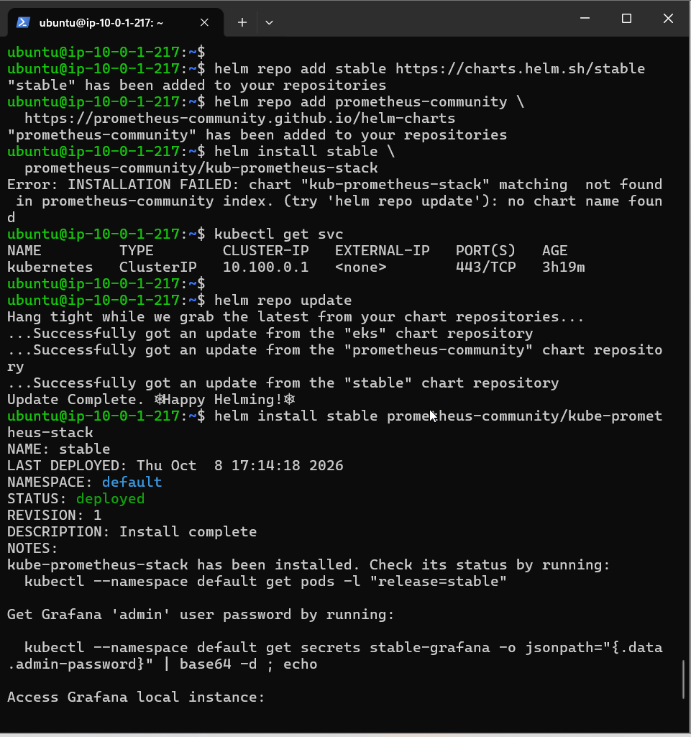

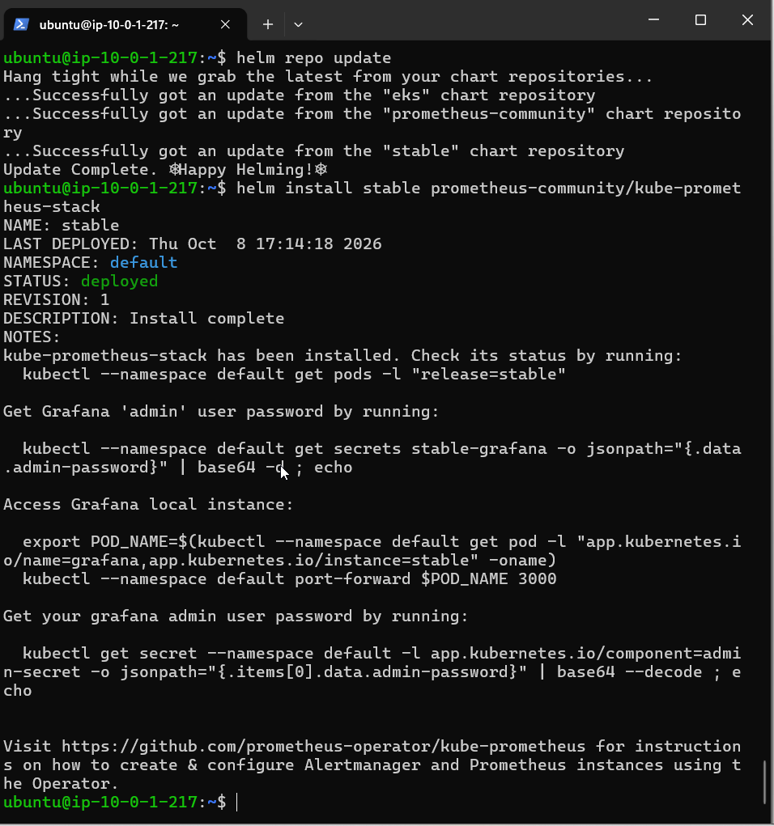

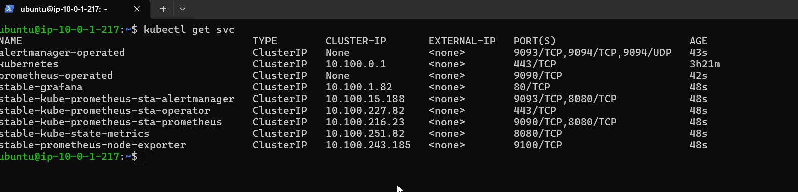

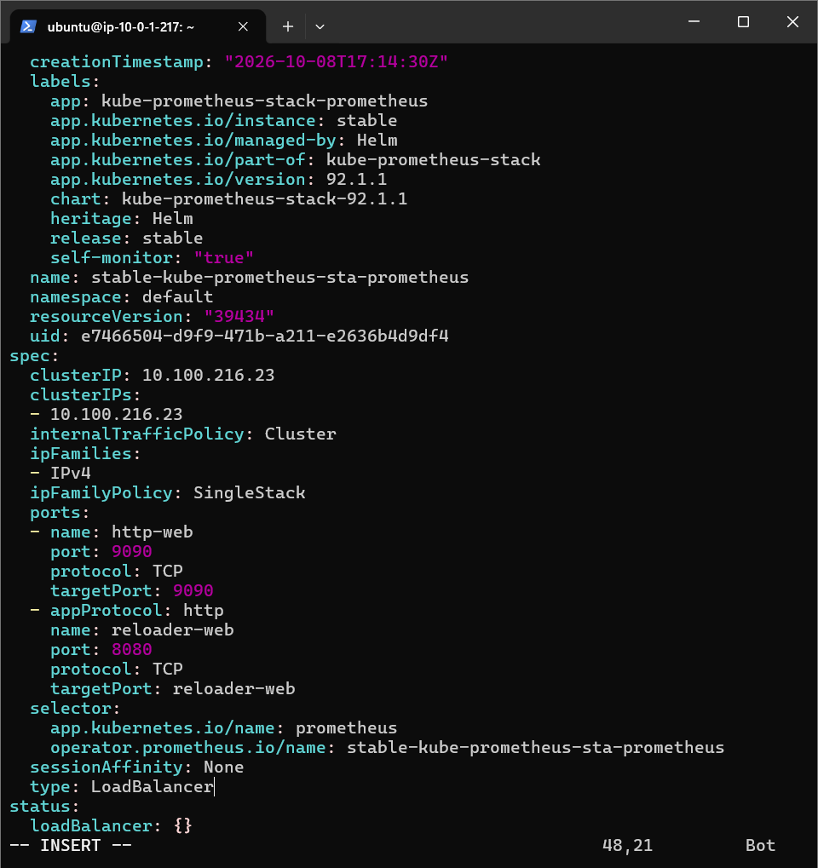

kubectl edit svc stable-kube-prometheus-sta-prometheus

kubectl edit svc stable-grafana

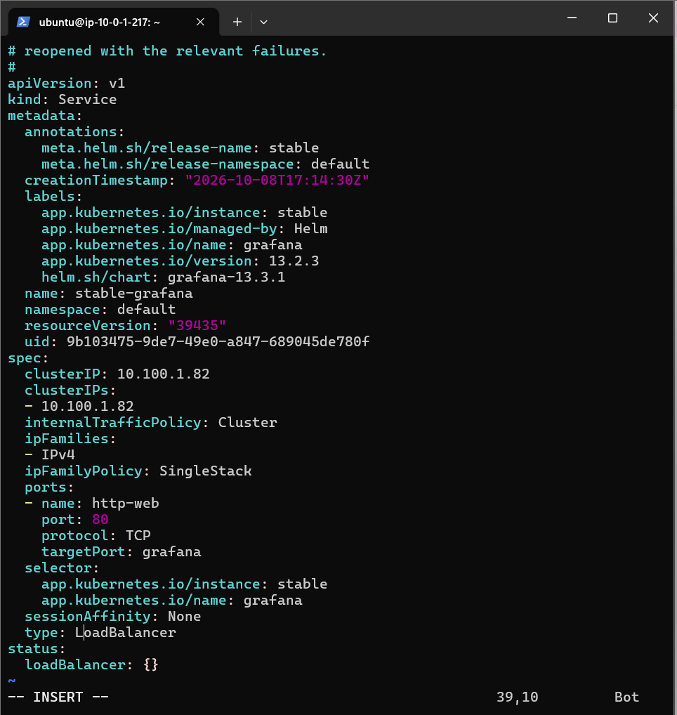

Changed to loadbalancer

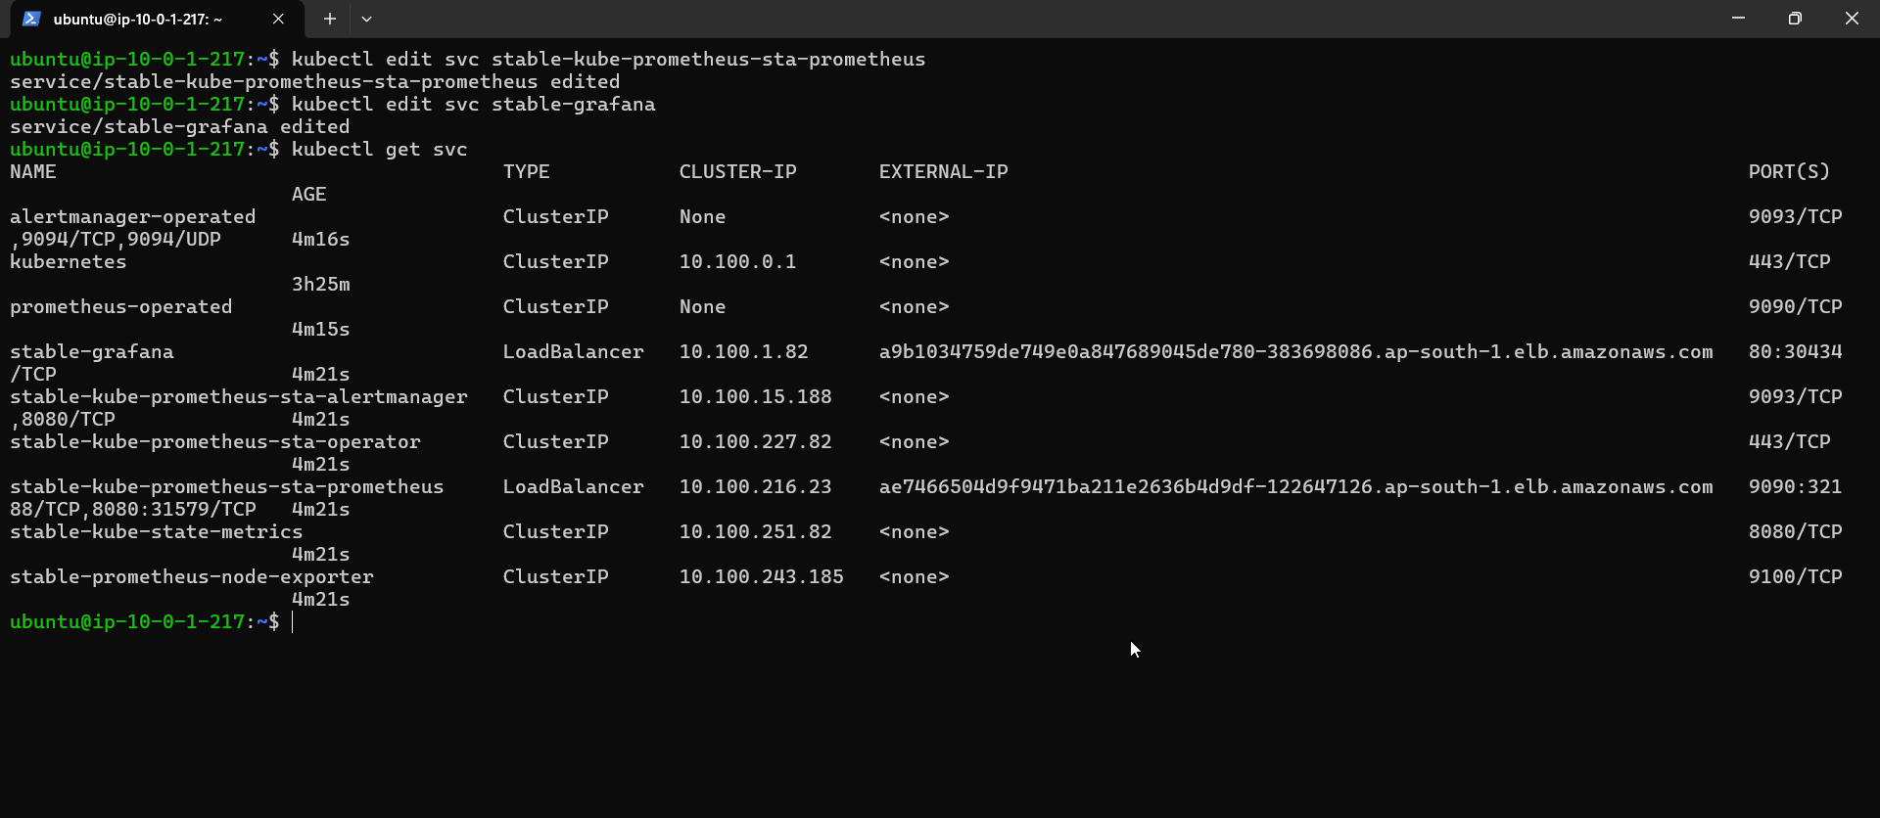

a9b1034759de749e0a847689045de780-383698086.ap-south-1.elb.amazonaws.com

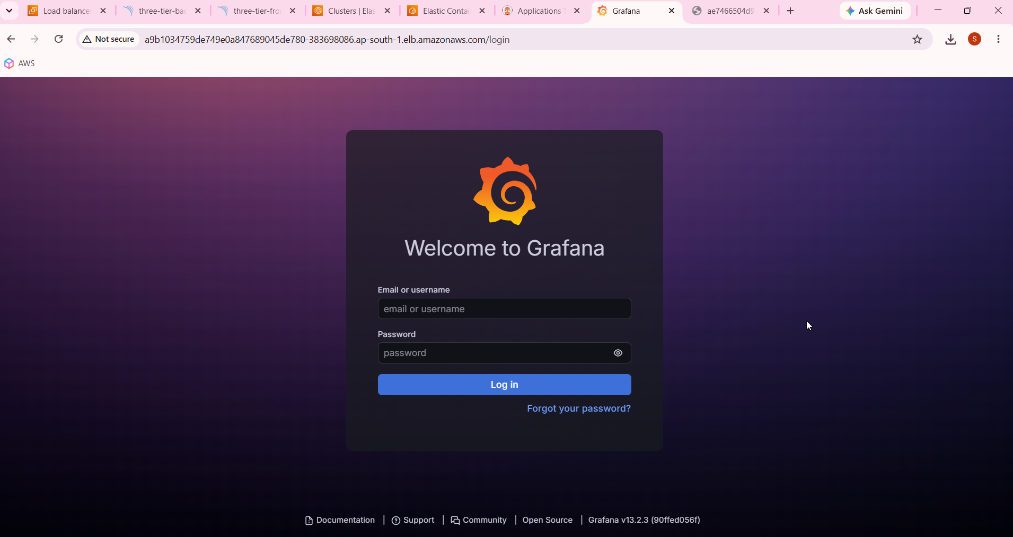

http://ae7466504d9f9471ba211e2636b4d9df-122647126.ap-south-1.elb.amazonaws.com:9090/query

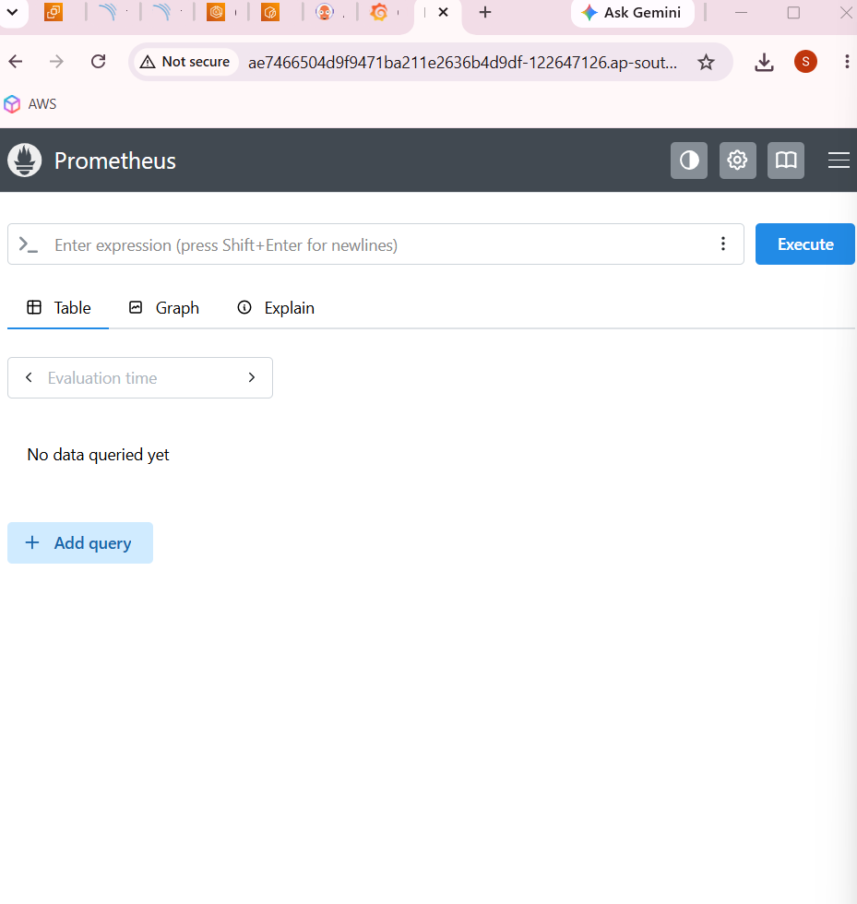

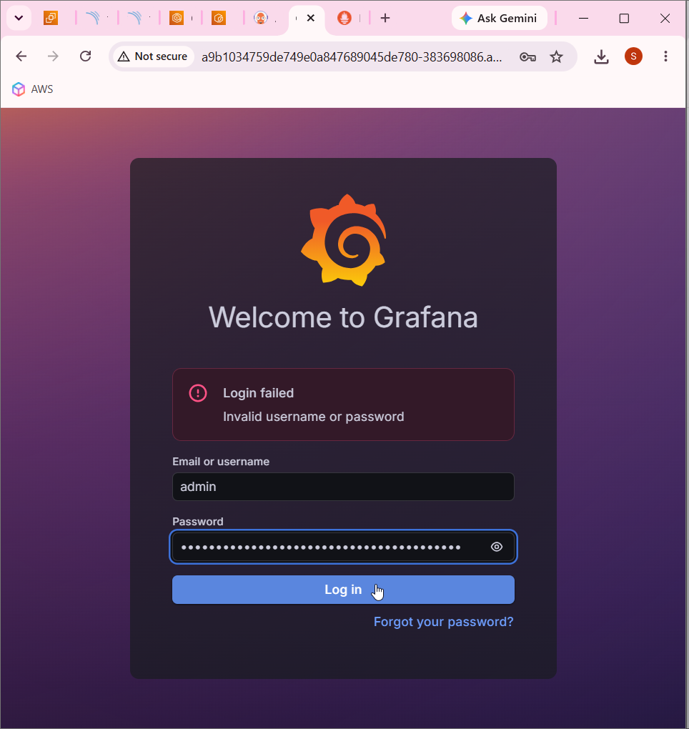

kubectl get secret stable-grafana \
-o jsonpath="{.data.admin-password}" | base64 --decode

21thm9cBtN09BldMtJ1XC52TDWyKynPFRJVvqHoE

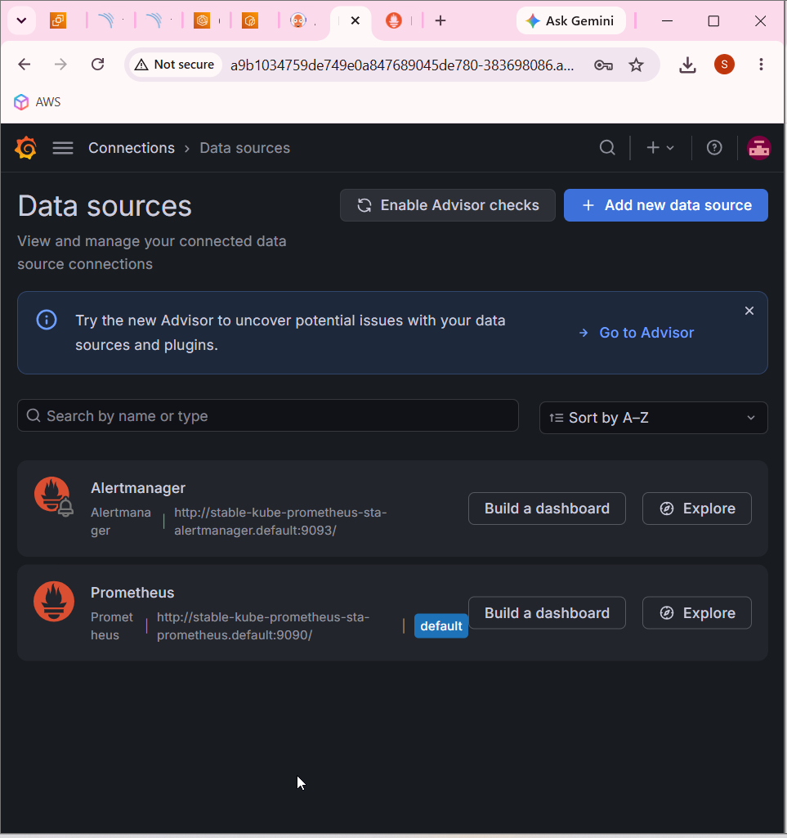

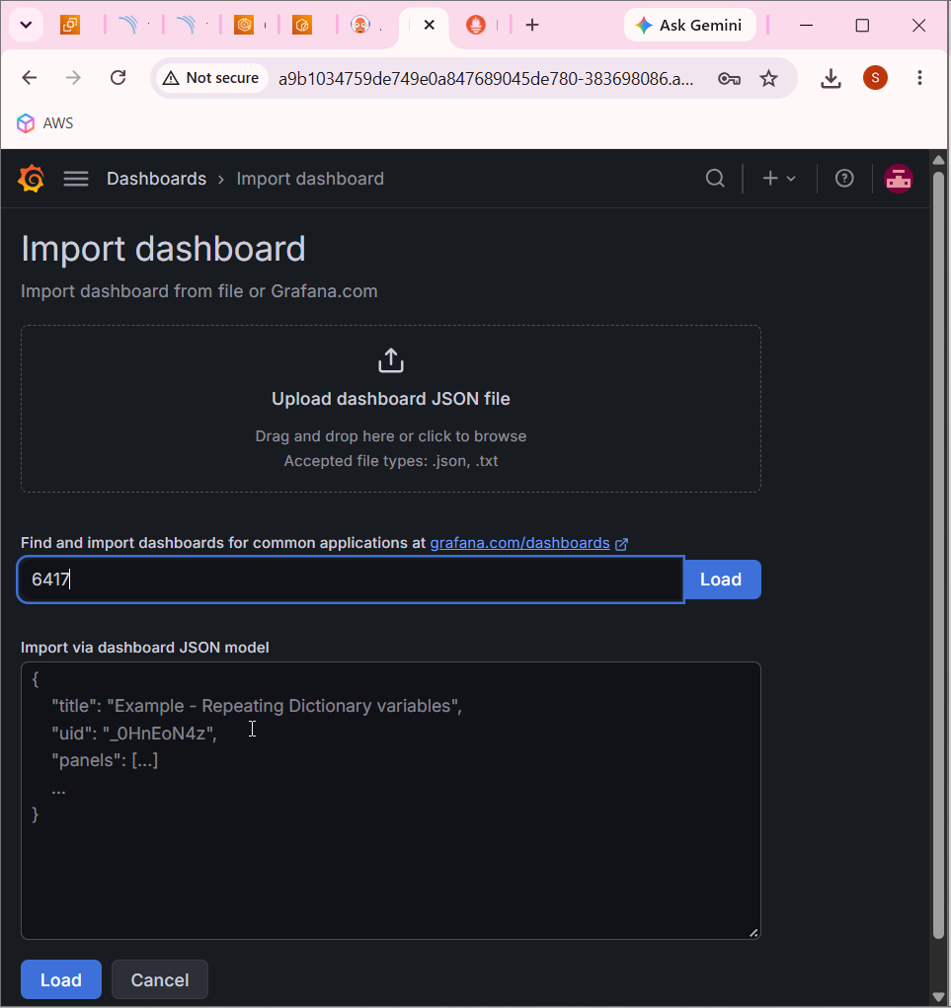

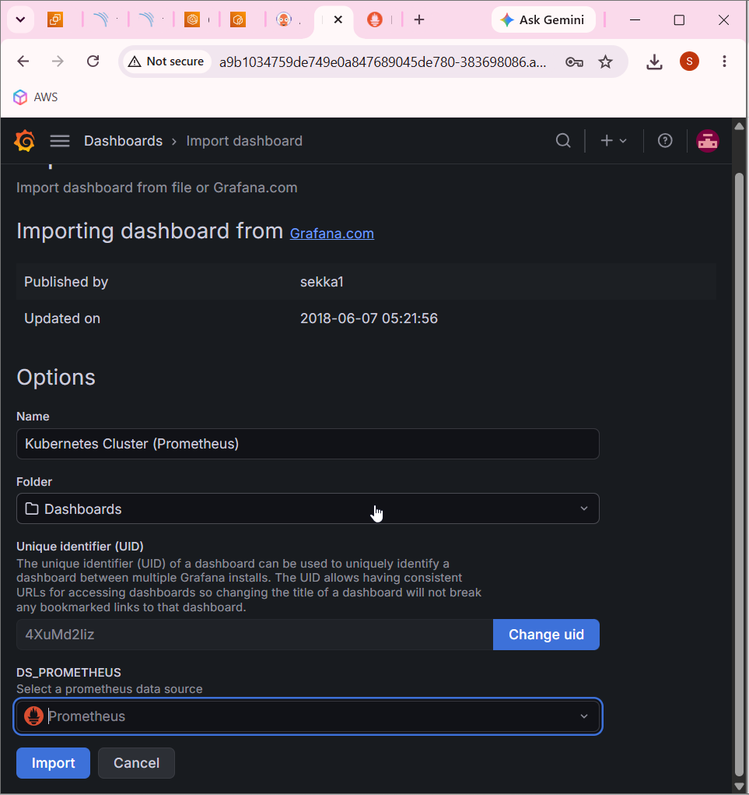

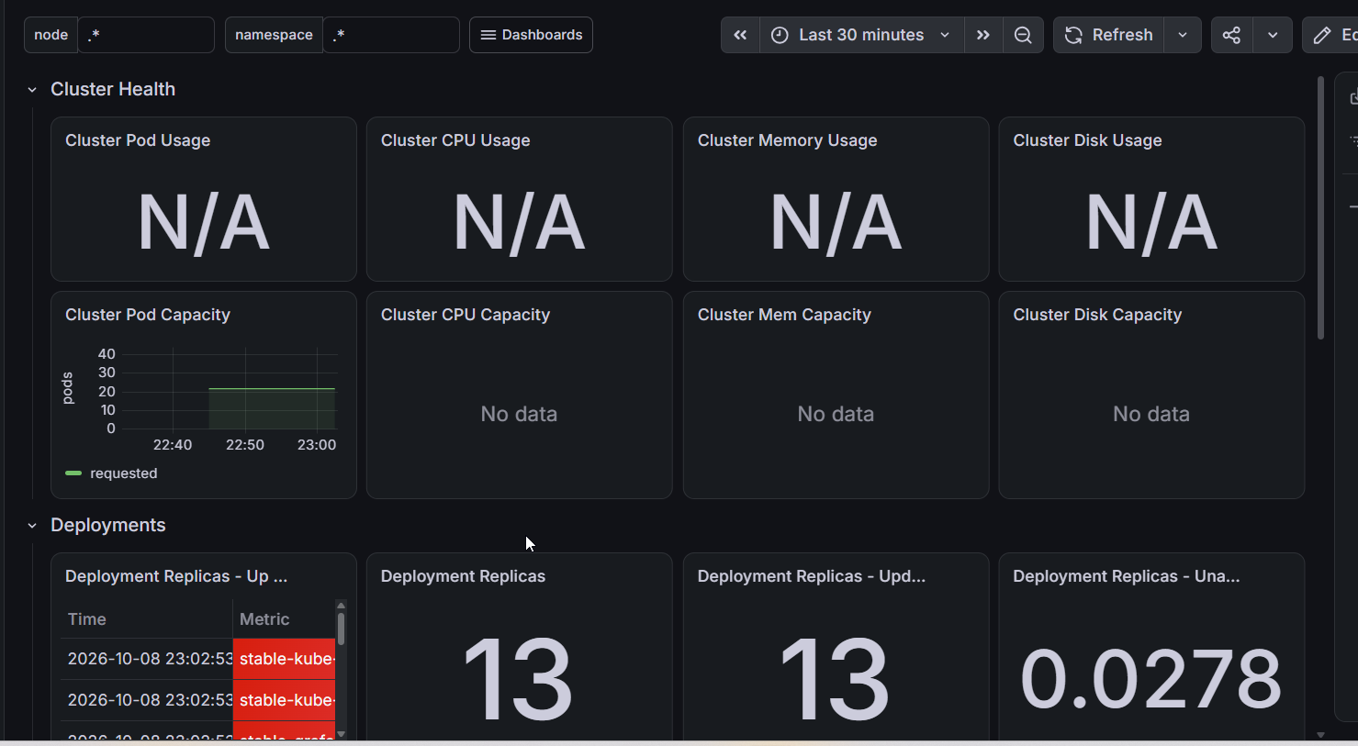

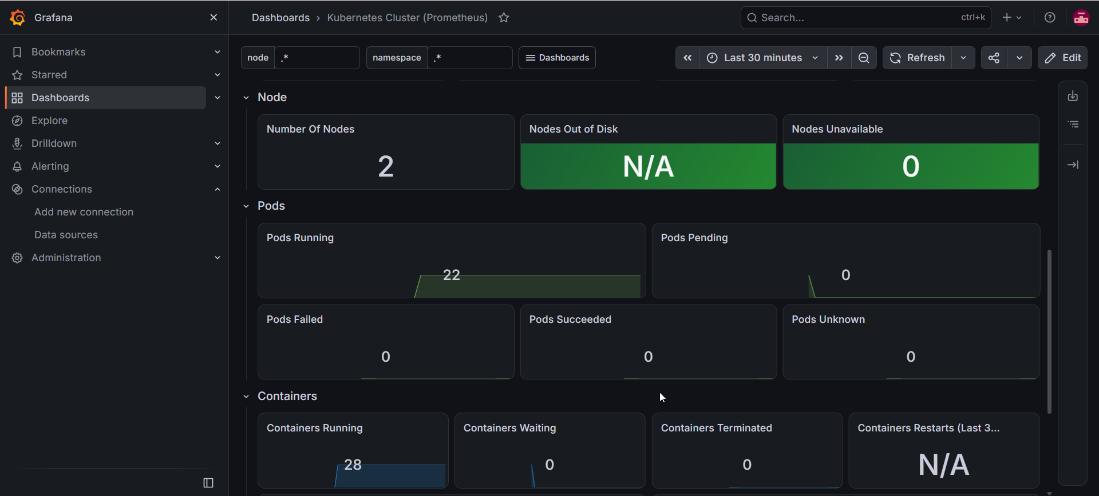

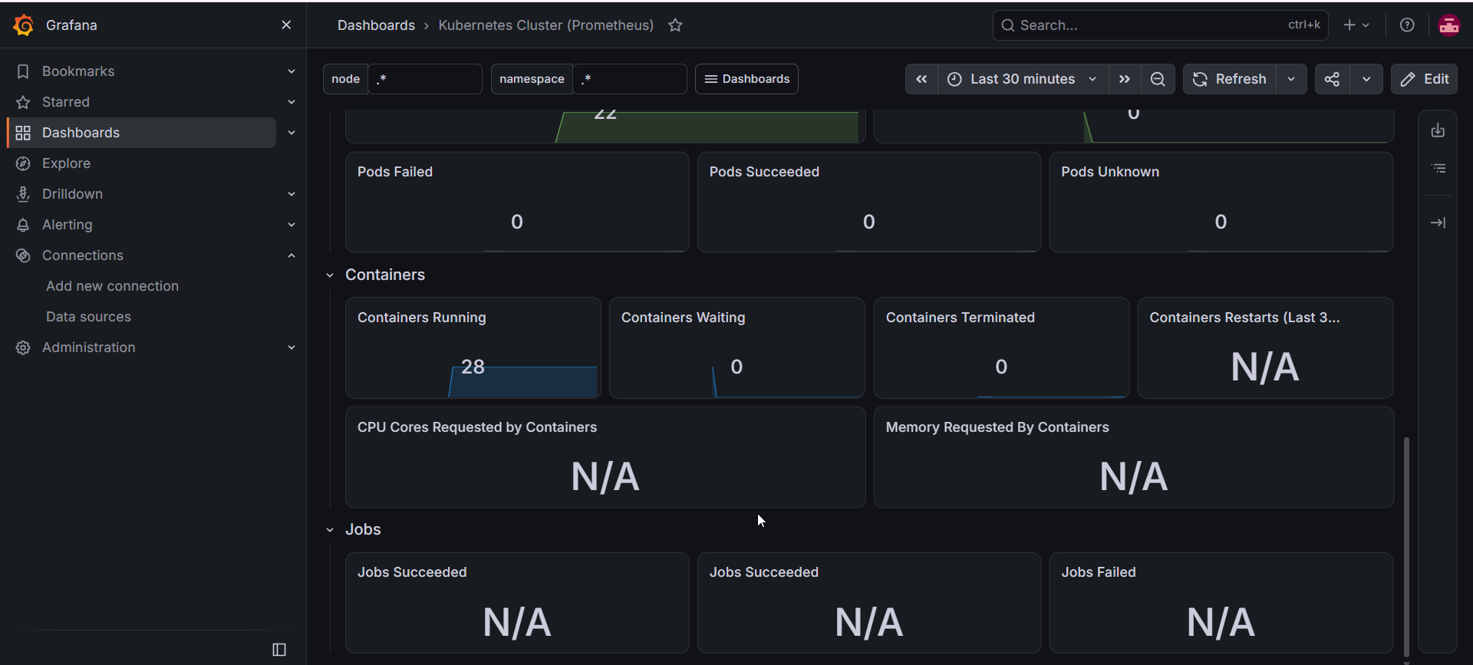
http://a9b1034759de749e0a847689045de780-383698086.ap-south-1.elb.amazonaws.com/

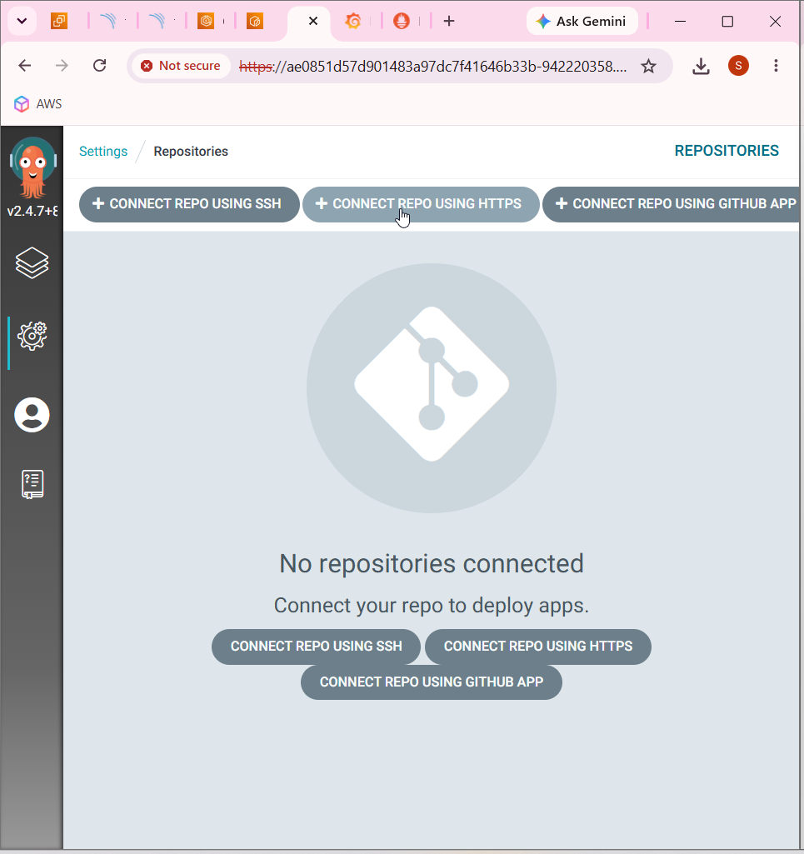

Connect repo using https

https://github.com/smarigurnathan/smari-three-tier-app.git

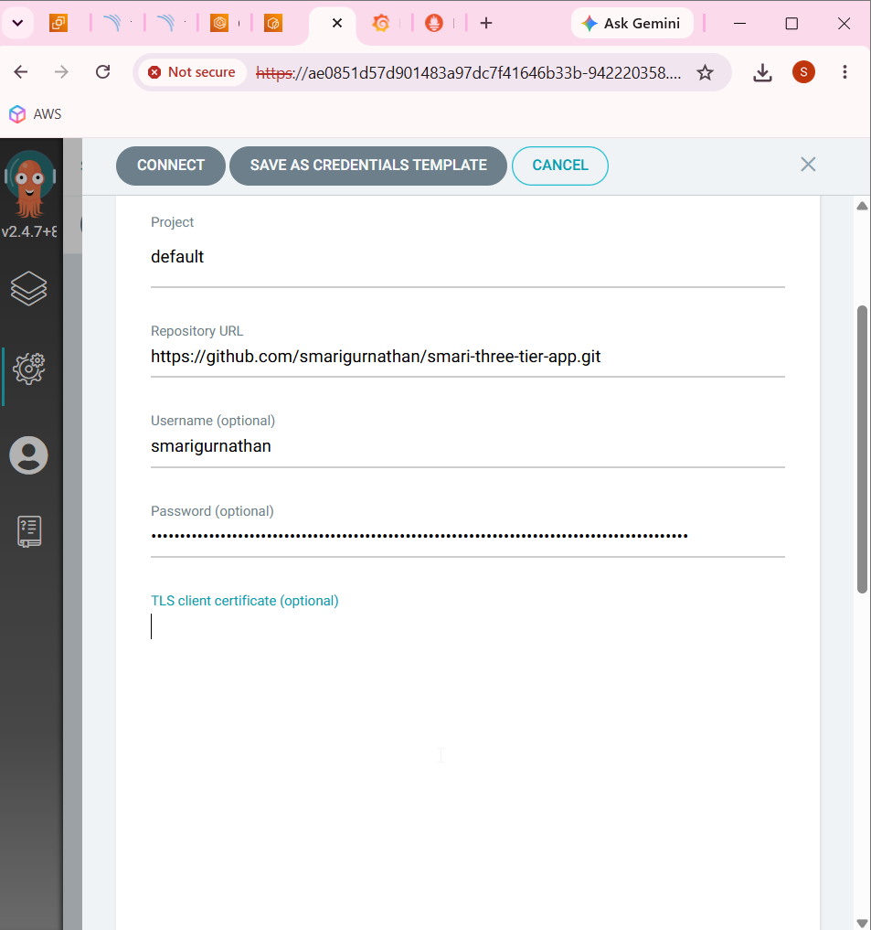

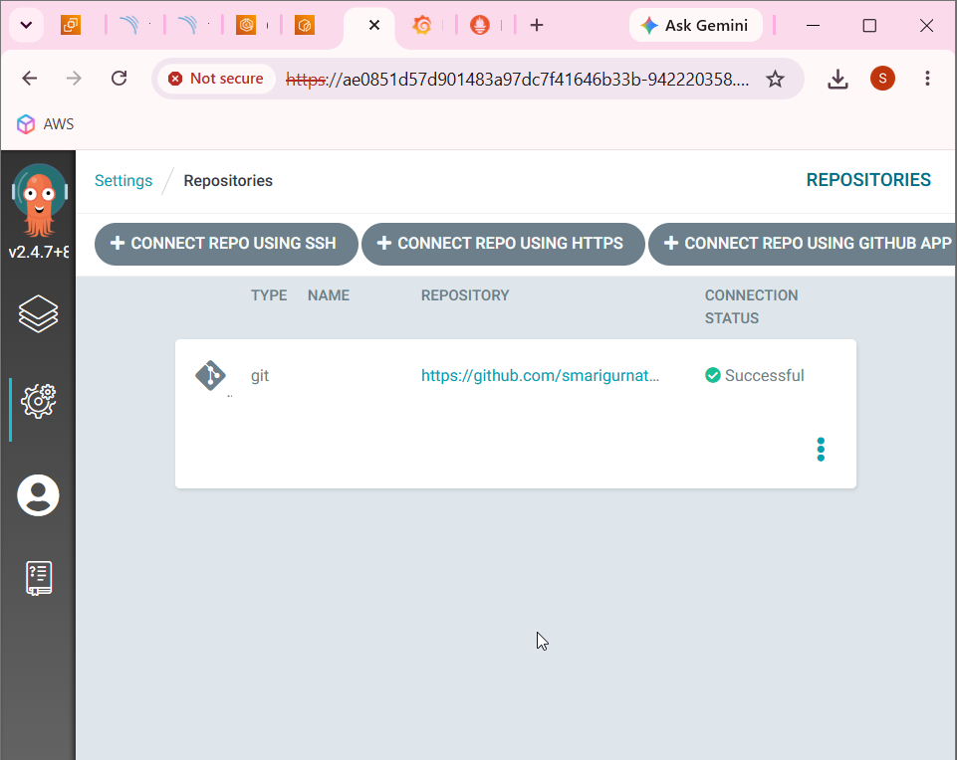

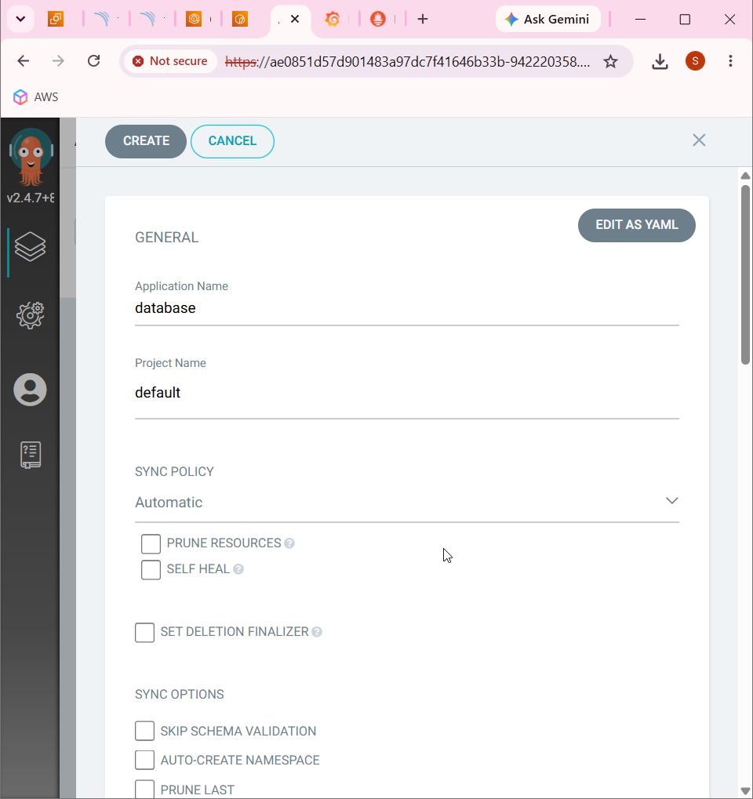

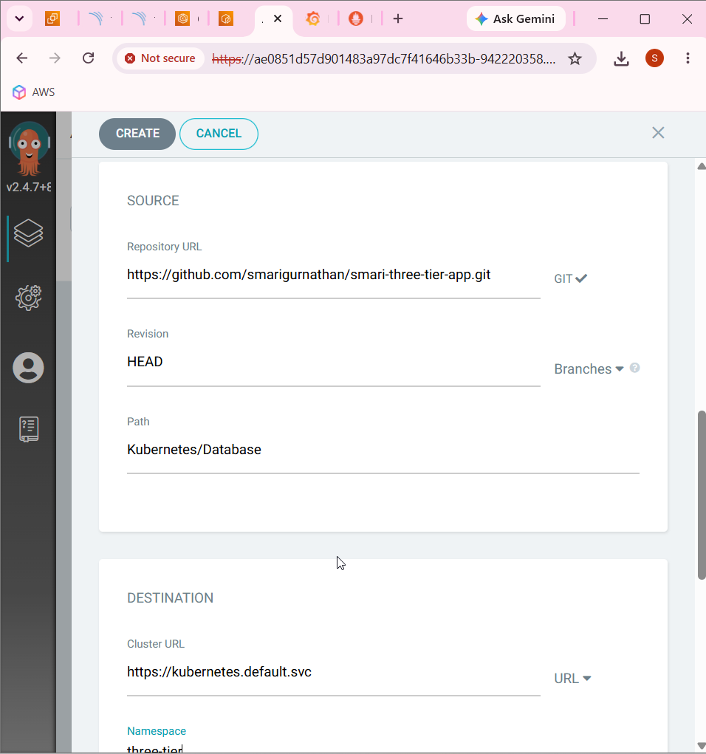

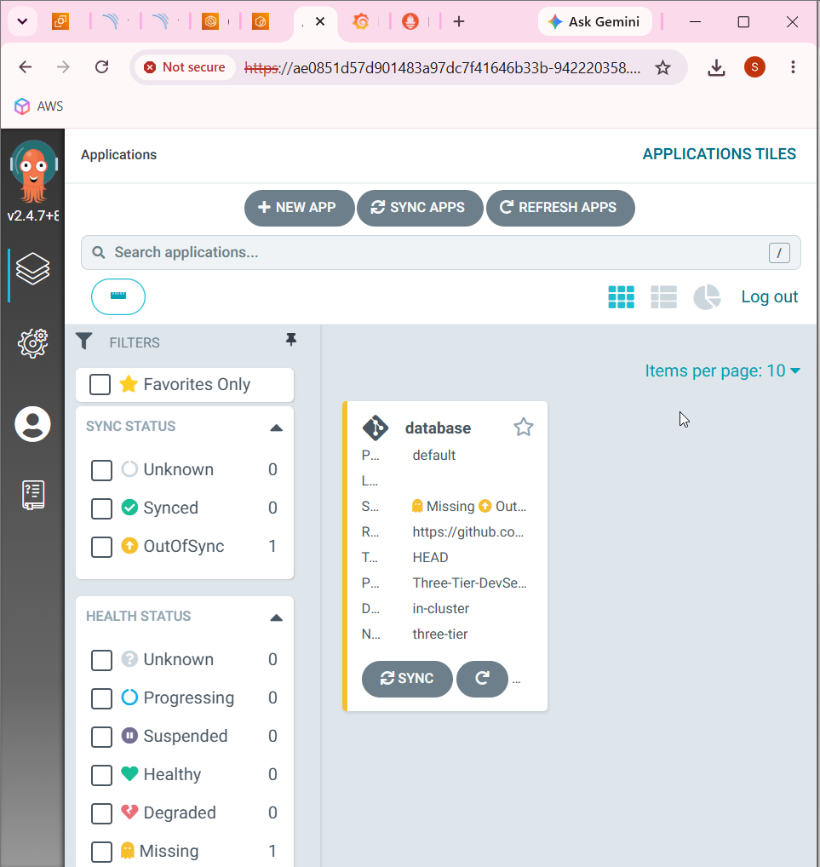

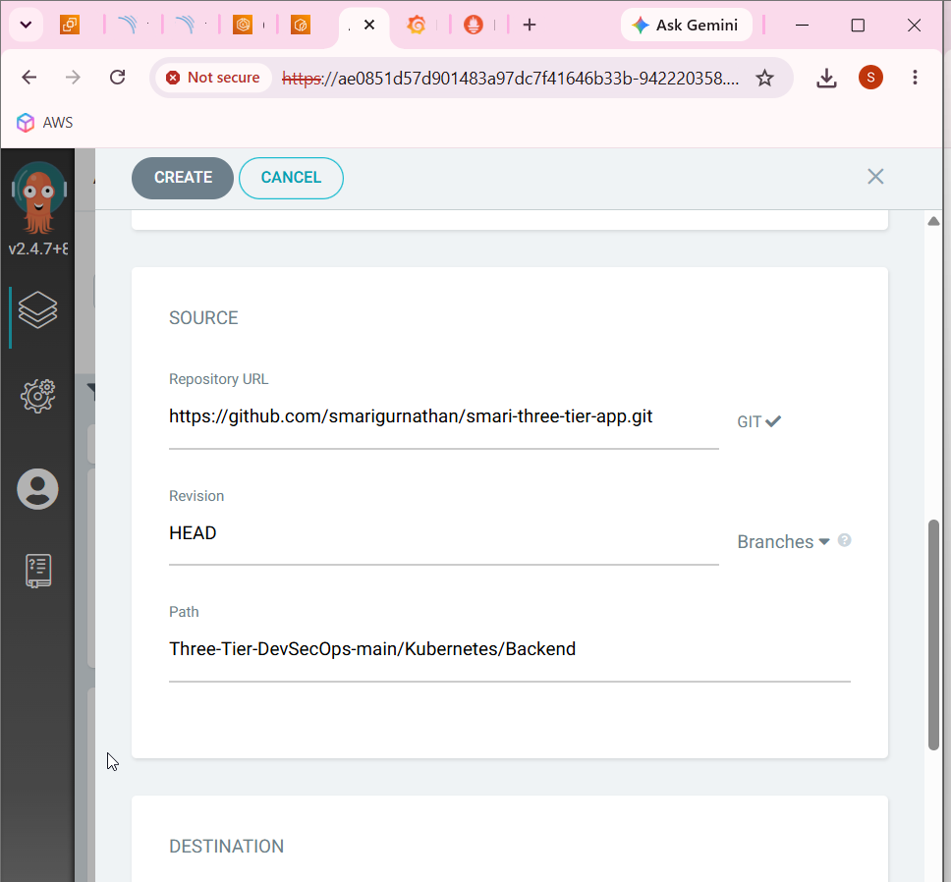

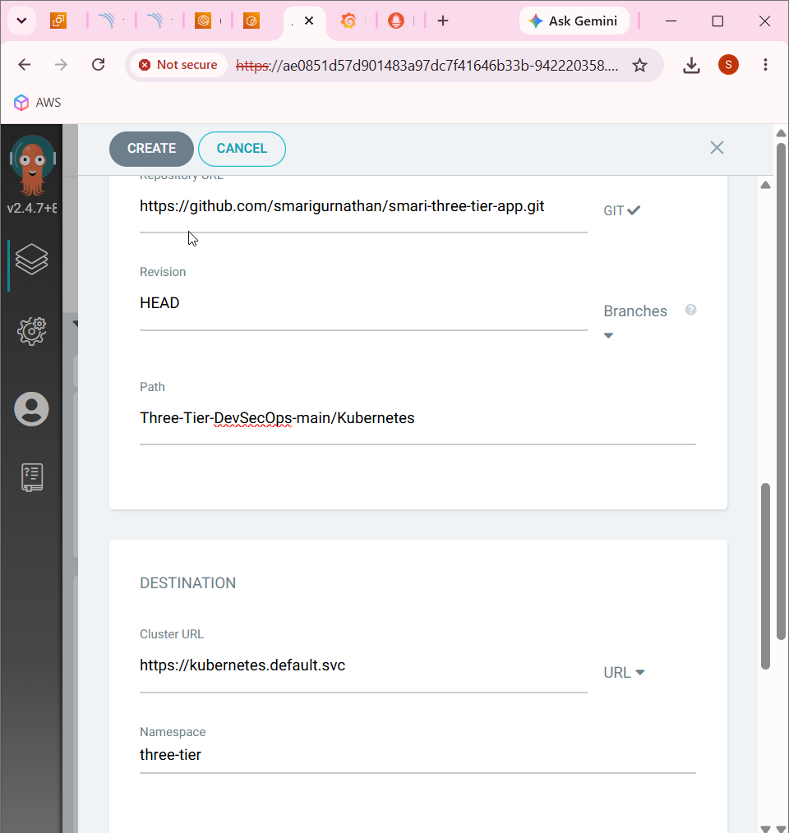

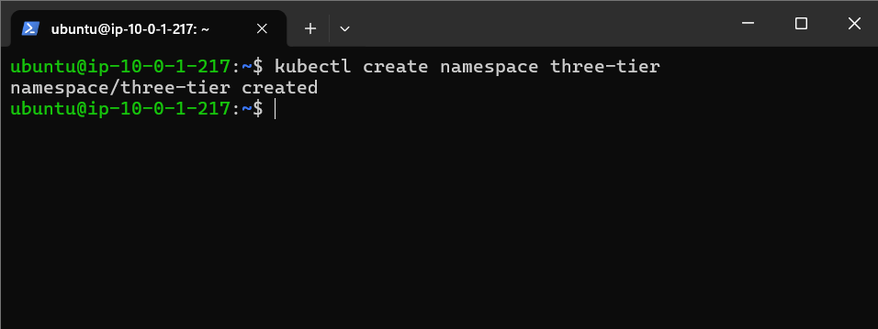

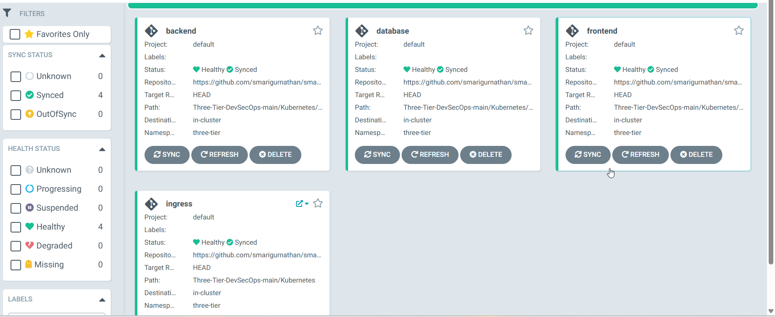

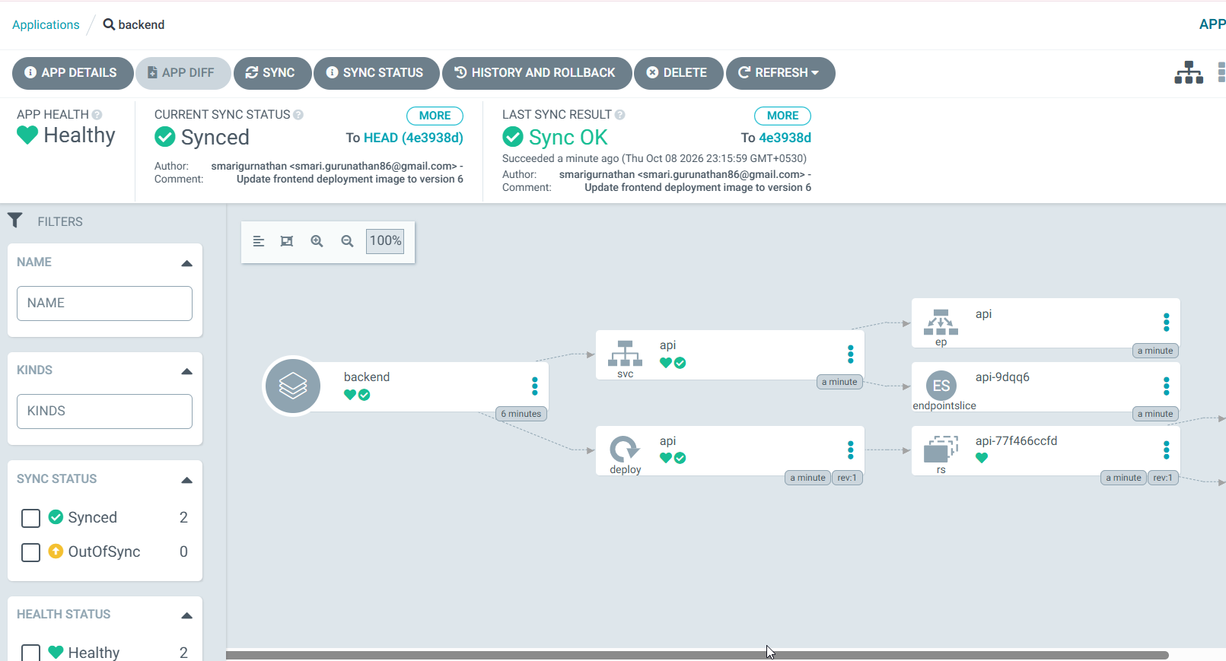

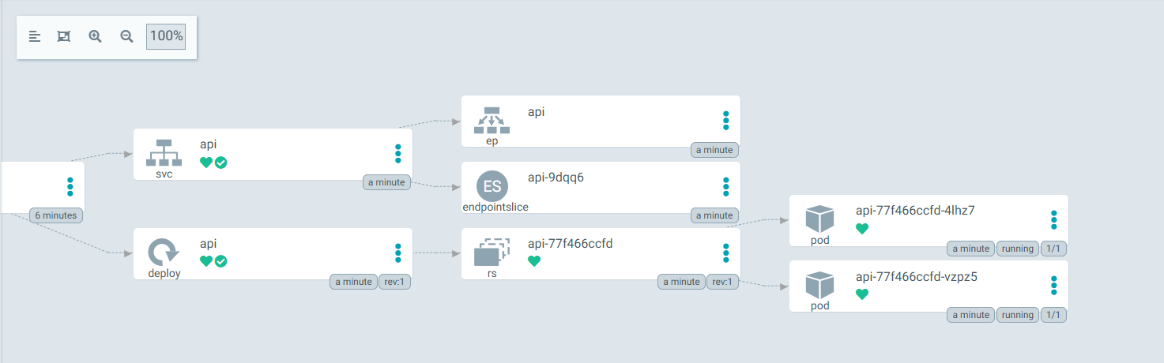

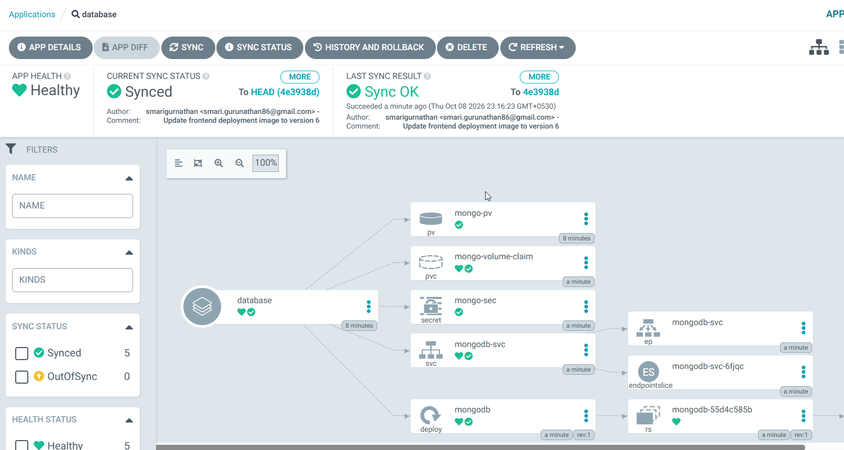

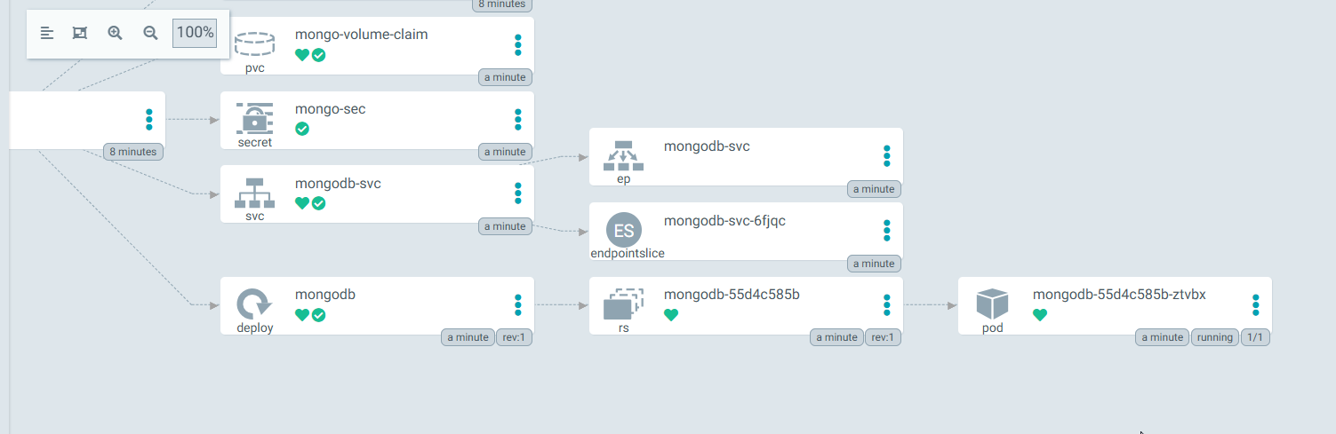

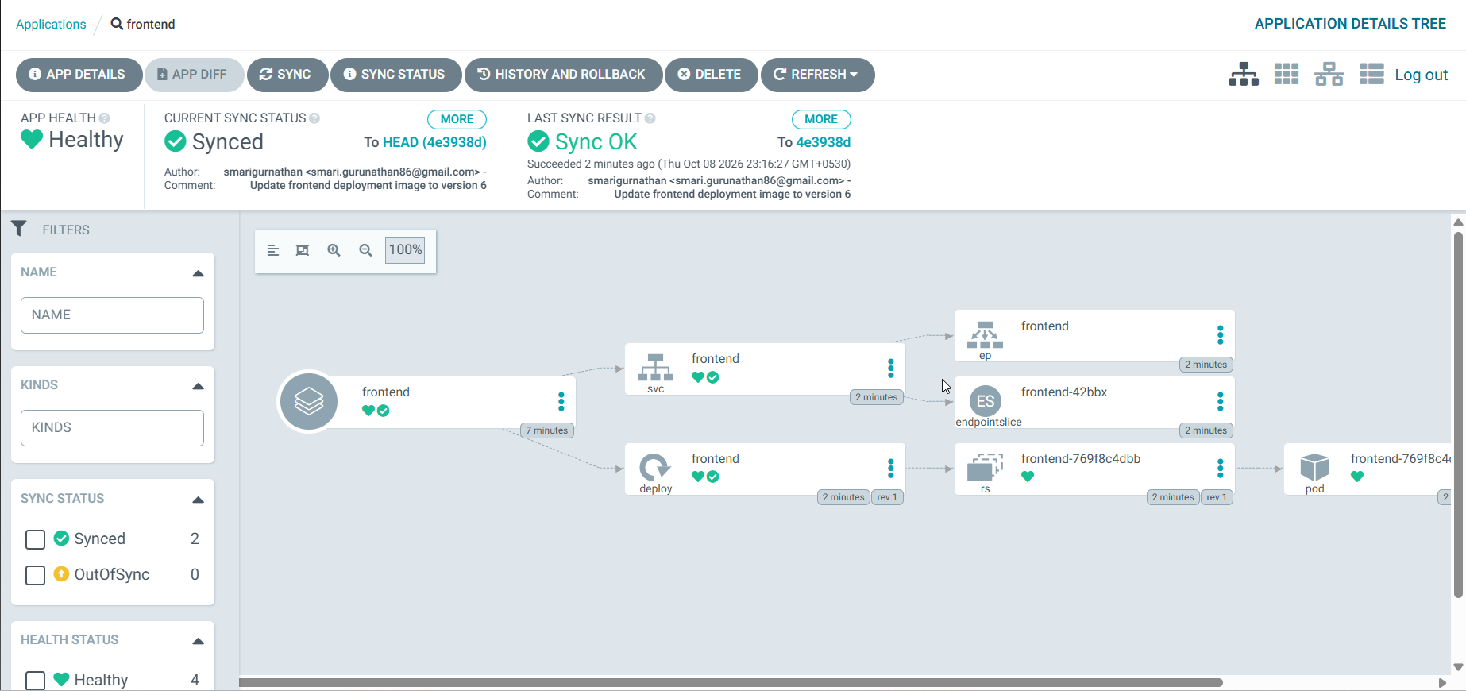

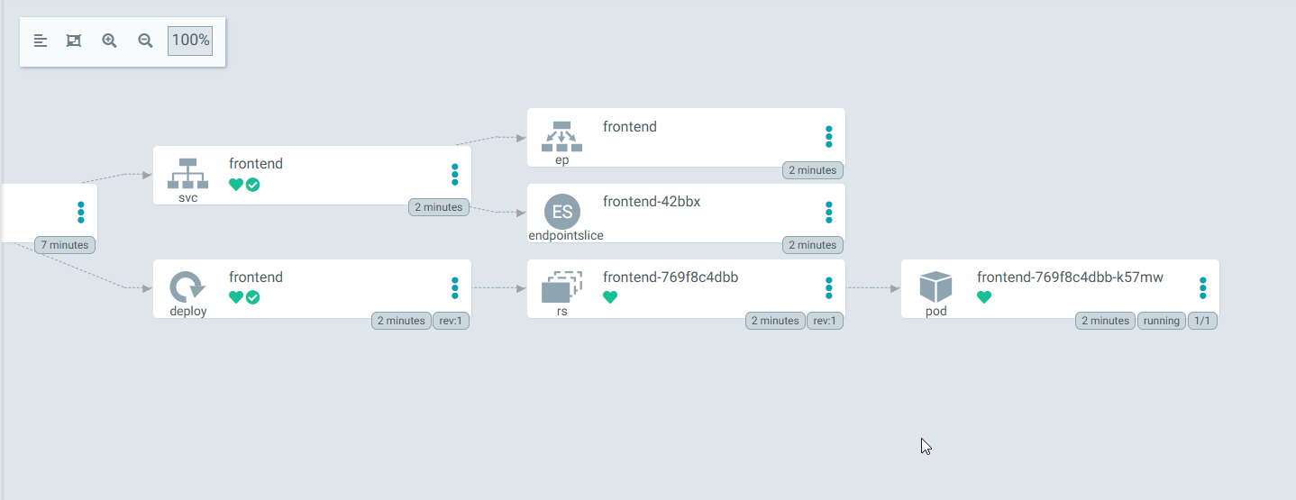

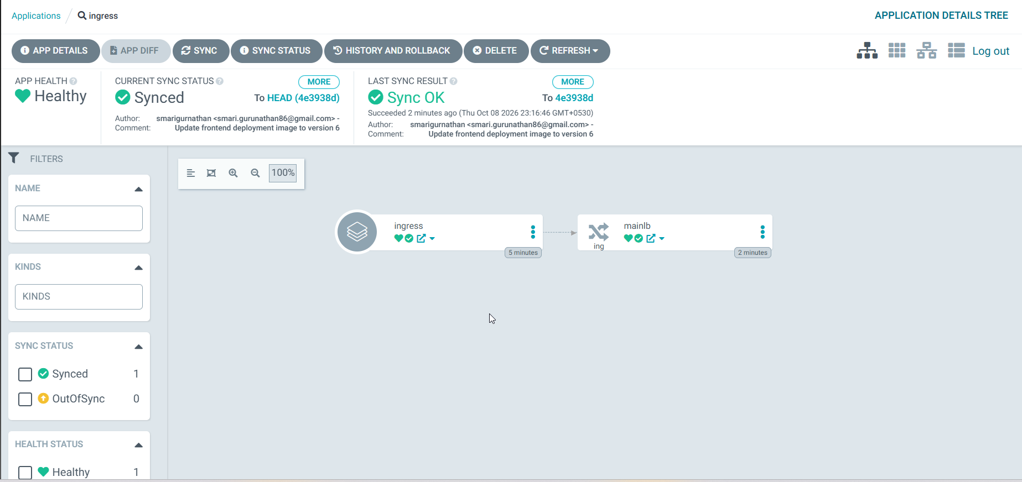

https://ae0851d57d901483a97dc7f41646b33b-942220358.ap-south-1.elb.amazonaws.com/applications

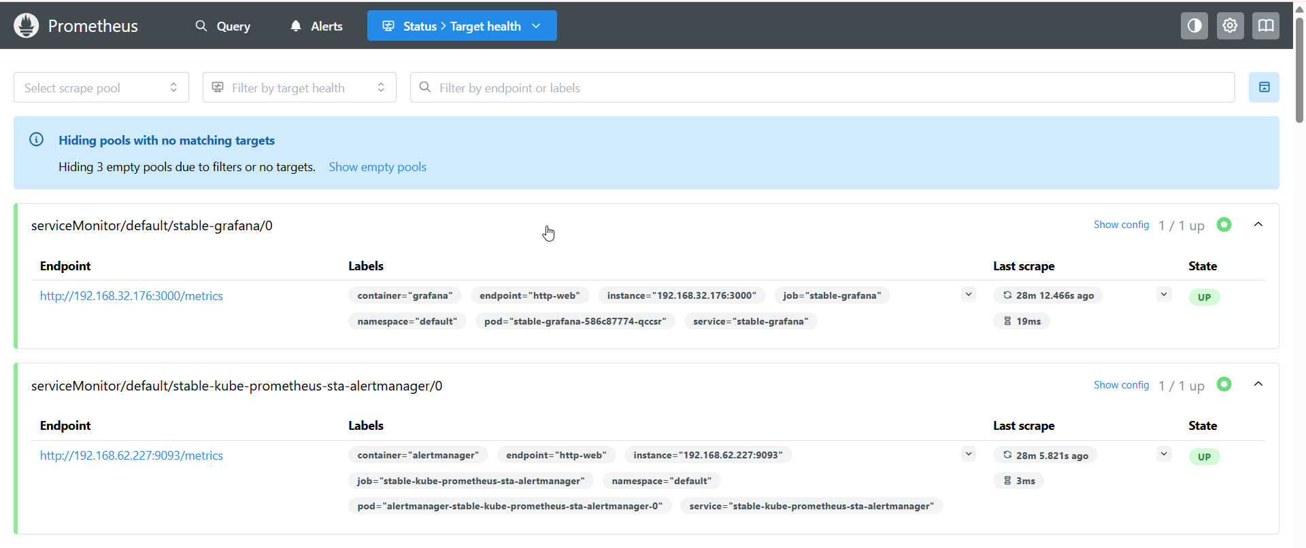

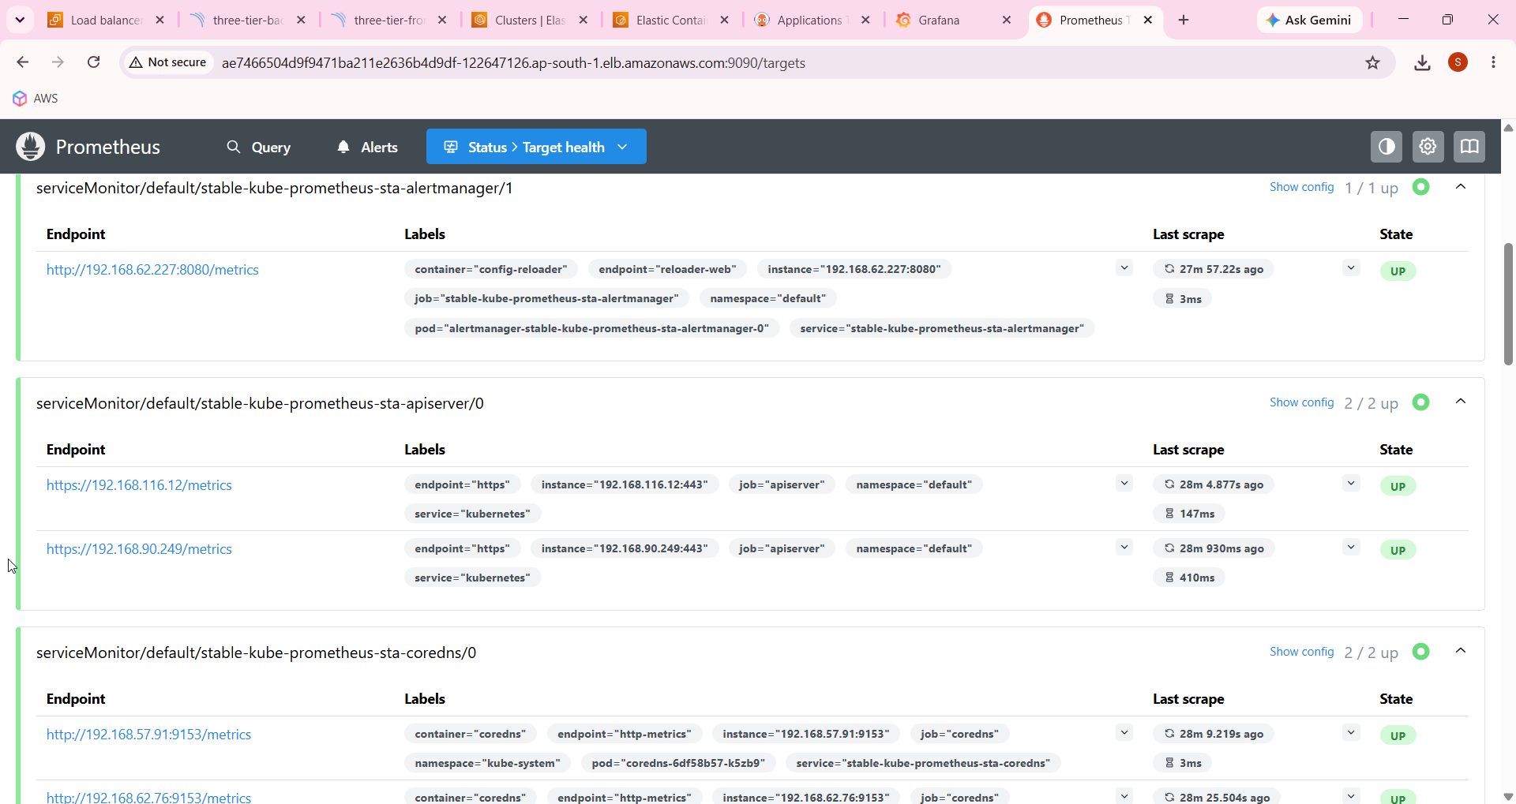

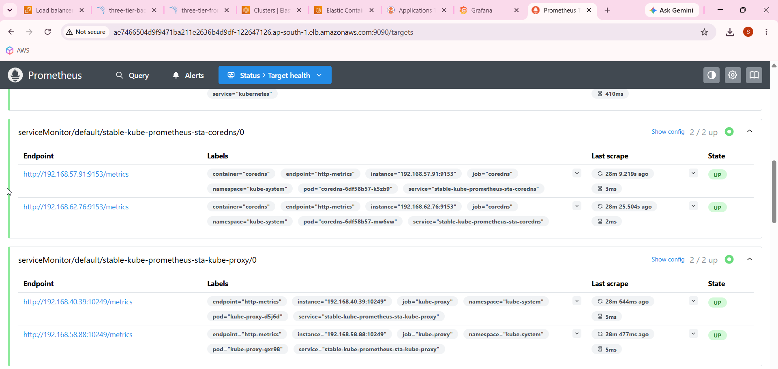

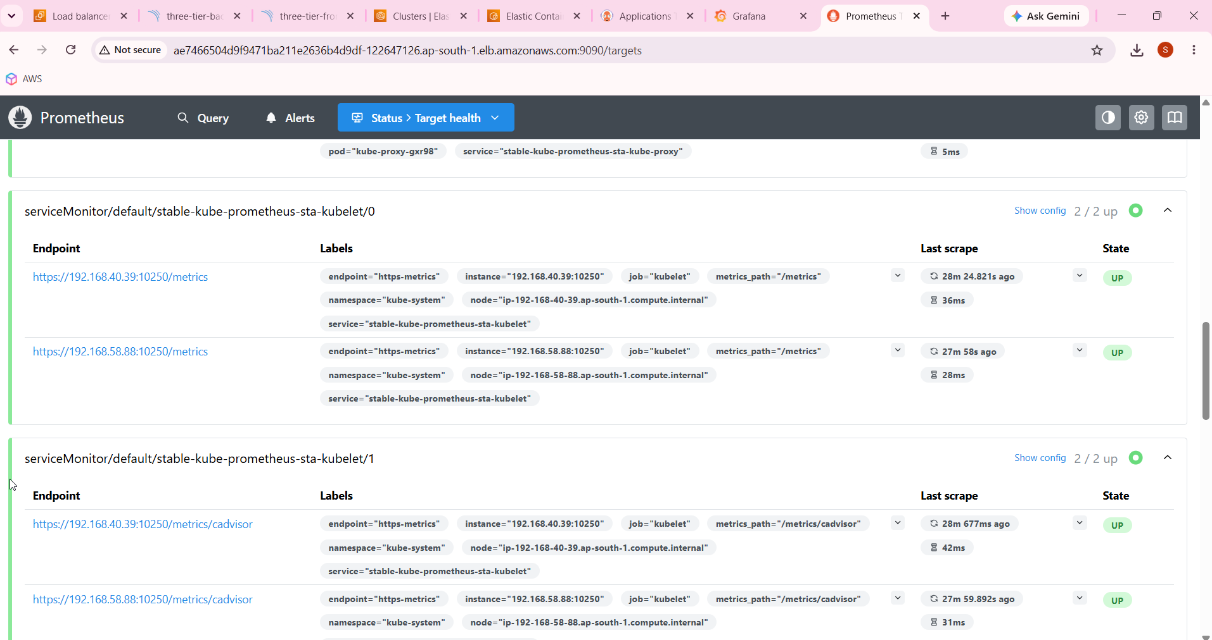

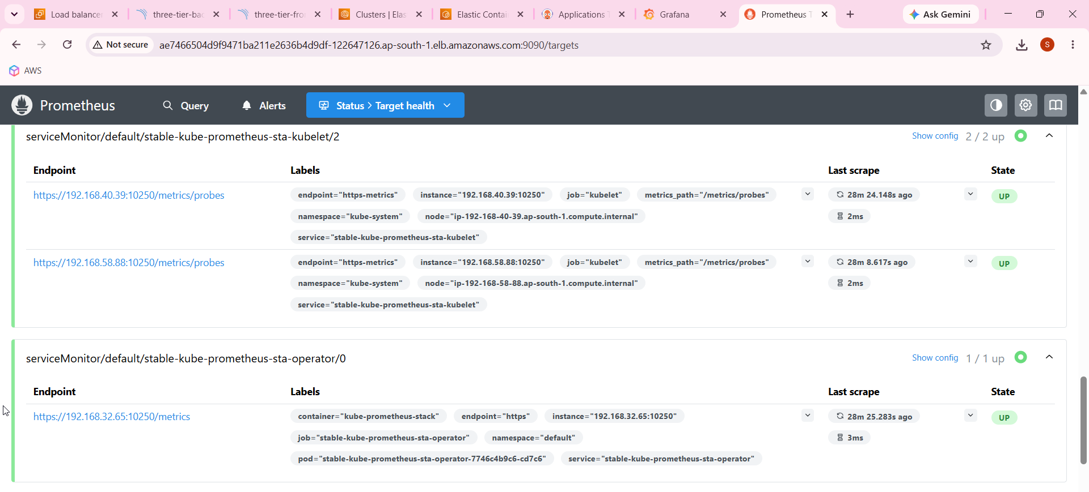

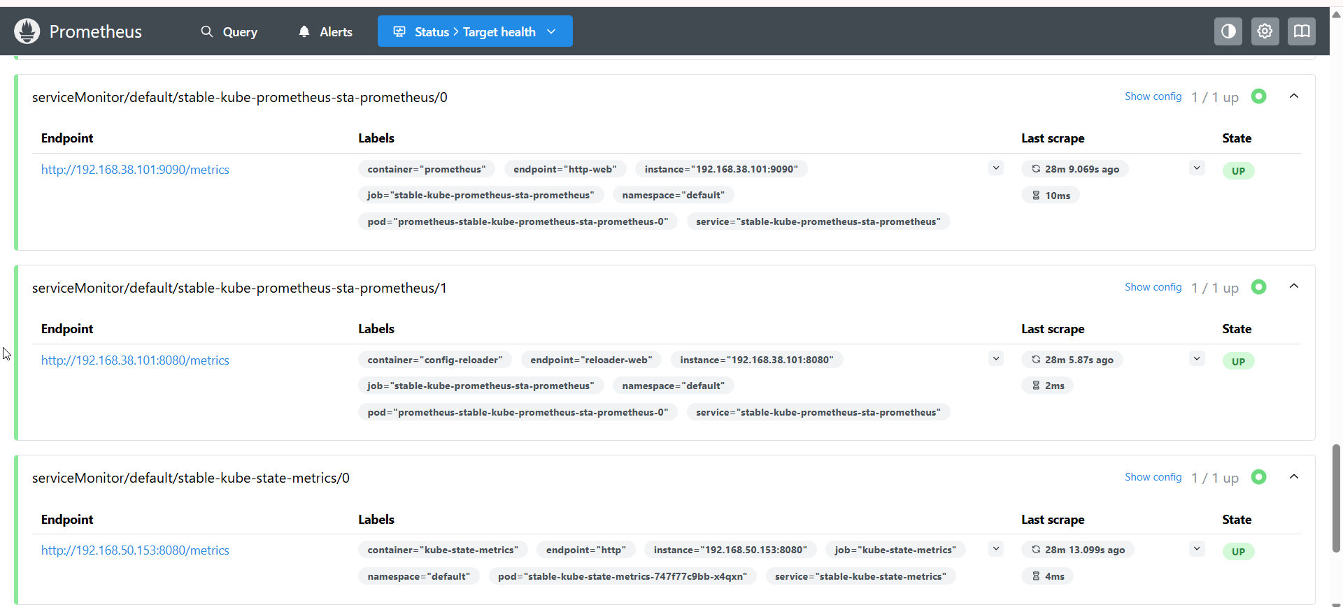

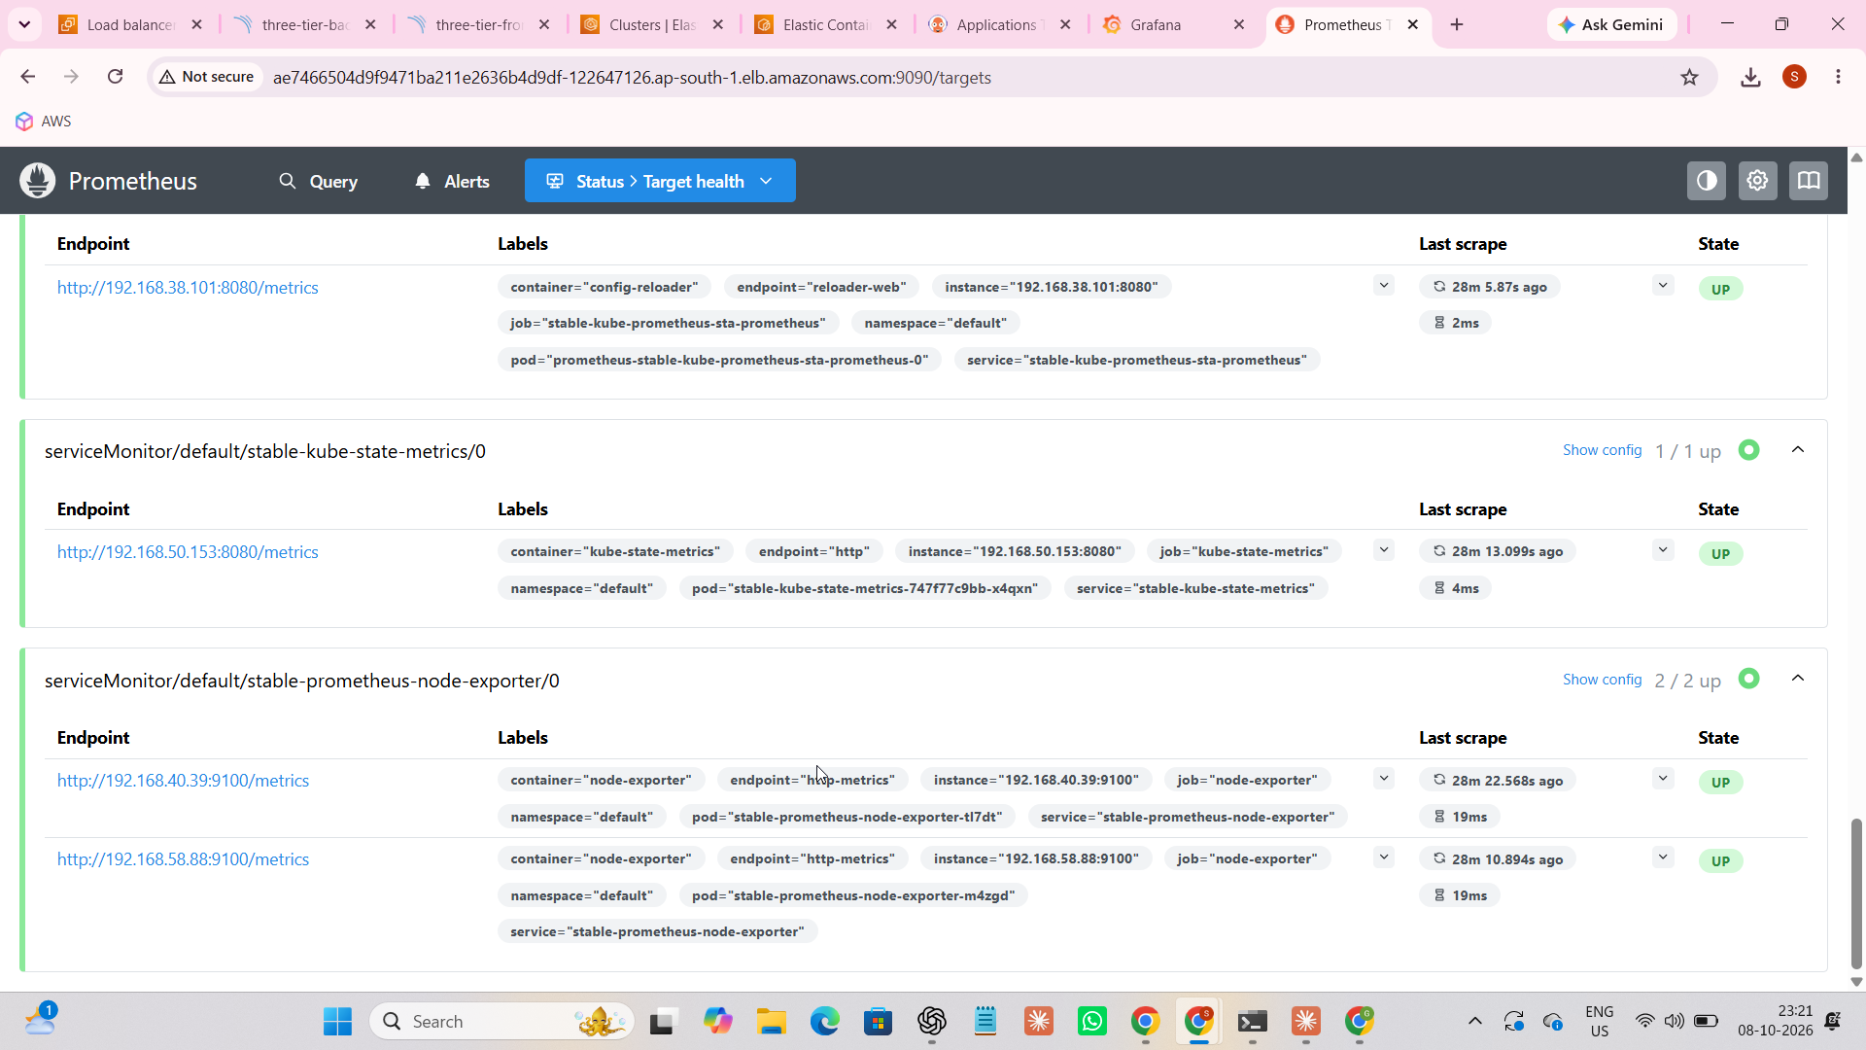
http://ae7466504d9f9471ba211e2636b4d9df-122647126.ap-south-1.elb.amazonaws.com:9090/targets




